Luxurious Glamping Resort, Glamping Structures Lodges – Design & Manufacture
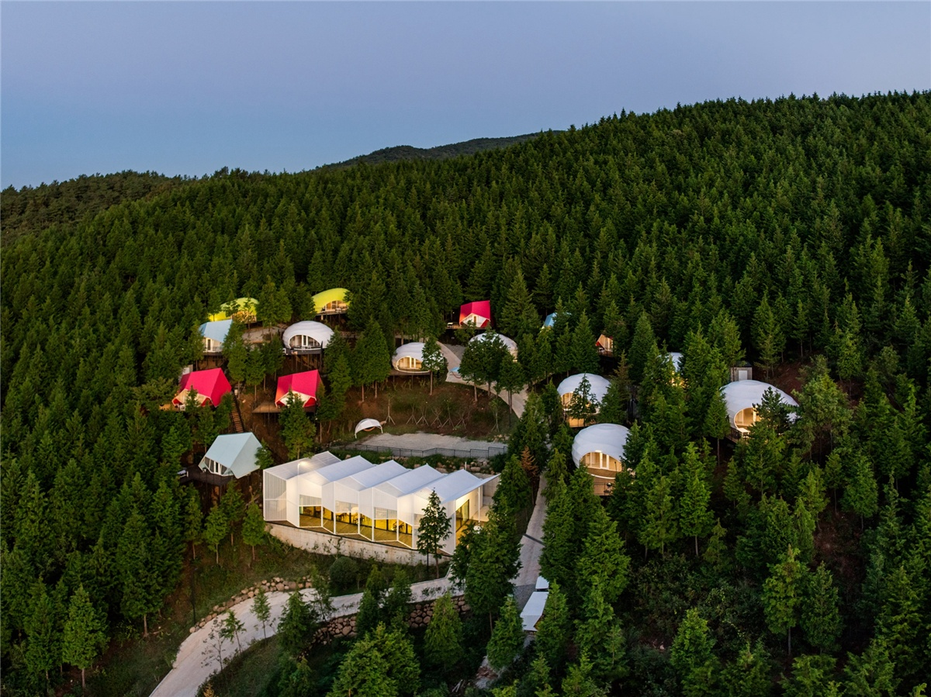
The Glamping Resort has designed a series of colorful tents to offer visitors a luxurious camping experience on a cypress-covered hill near the city.
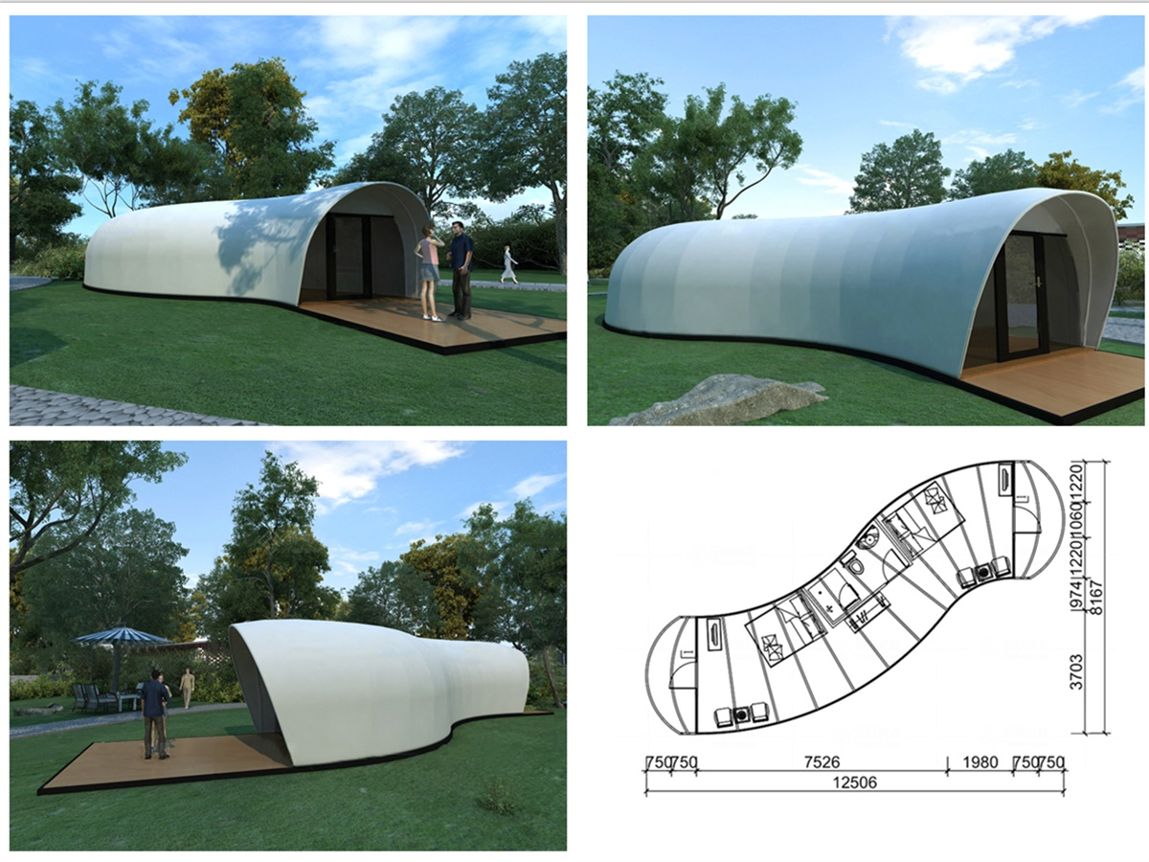
The 16 bright tent pods are positioned to enjoy the view of the Eco Bay. A double-layered fuchsia, lime-green or light-blue fabric unfolds over the steel frame to form a pod that is insulated enough to survive throughout the year. The chamfered and curved shape of the steel frame structure is designed to help withstand wind and snow loads. Each tent pod is fixed to a wooden deck that is stacked on top of the terrain to minimize the impact on the site environment (forest land). Inside, the 50 m2 floor plan can accommodate two beds on the mezzanine level, as well as an open plan lounge and kitchen as well as a bathroom. When you go camping normally, which is completely different from the narrow range of the tent, so if you want to experience the rejuvenation in the absence of uncomfortable outdoor activities, this is a good starting point.
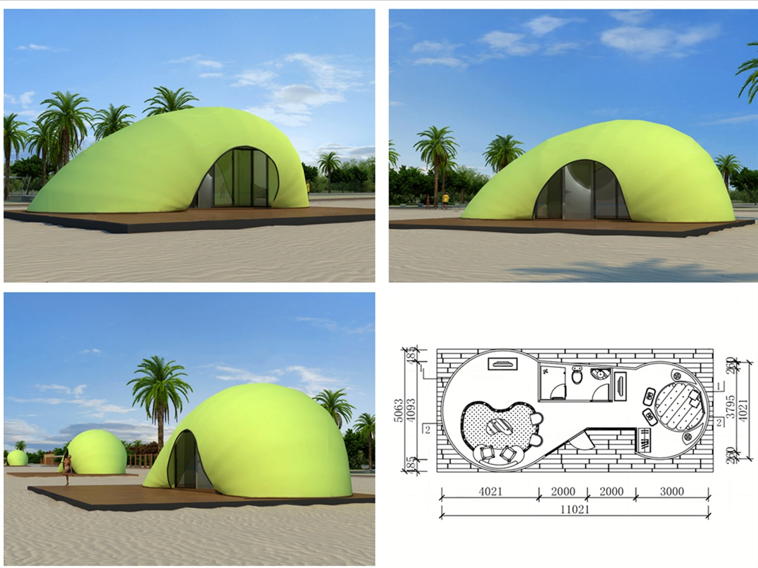
The Glamping Tented Resort has a clubhouse and restaurant, which is crafted from the same steel and fabric construction techniques as the camping pods, and has a zigzag white steel shuttered façade that leads to the mountain-facing terrace and admire the valley below for magnificent views.

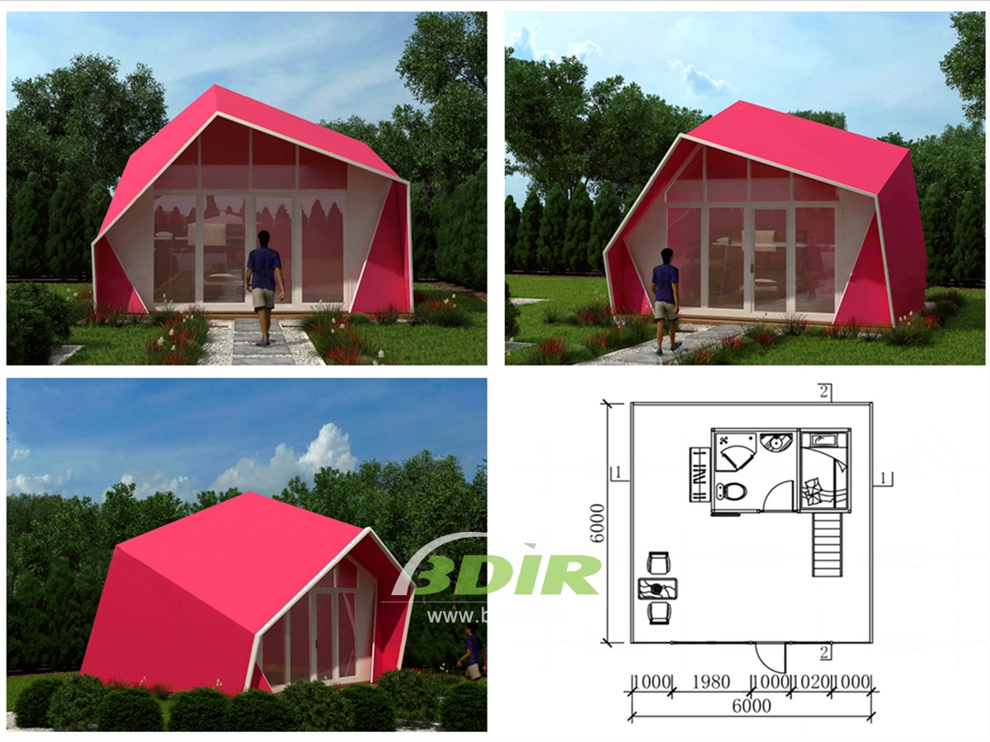
BDiR Inc. Design, manufacture, installation, maintenance Luxury safari tent resort, glamping tents, eco-lodges and resort tents at very reasonable prices. We ship canvas tents worldwide for all purposes. No matter where your tent or camp will be located in - be it on water, rocks, desert, sand, a grassy plain, tropical beach, ice field or in dense rainforest - we will ensure it is built to last.

