Lodge Tented Hotel - 5 Star Luxury Tent Cottages Lodges
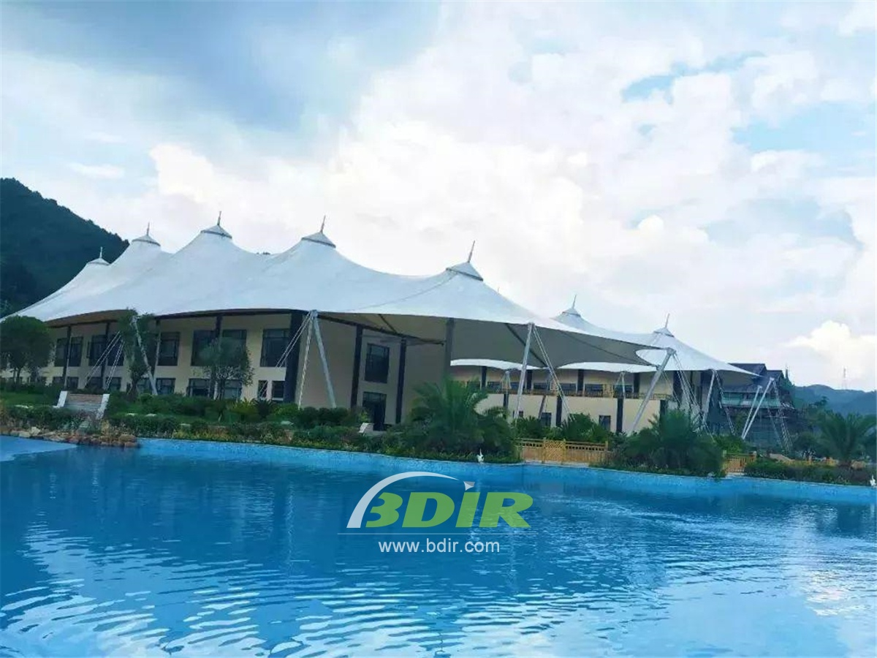
Bagan Lodge is an oasis in the ancient temples of Bagan, the majestic city of Myanmar. Located 700 kilometers north of Yangon, Bagan is home to the most concentrated ancient Buddhist sites in the world. After visiting a large number of pagodas and temples in a hot, dusty day, This hotel on the outskirts of the archaeological area undoubtedly allows visitors to recharge and process the rich historical buildings they explore every day.
Designed by French designer Brigitte Dumont de Chassart, the tent cottage hotel is designed with the central pool and everything around it. The bar, restaurant and lobby are open-air and overlook the luxurious water features.
The 82 tent villa rooms look a bit dull, but when you walk in, you will be struck by the exquisite interior design. The tent room with The large, comfortable bed and the wicker closet in the corner of the room. The tented room has a seating area with armchairs in one corner, a table and table in the other corner, and ample luggage space. The doors at the back of the room are located on either side of the bed, leading to some of Bagan's largest bathrooms, which have double sinks and a central bathroom with separate toilets and showers at each end. Half of the tent villas are interconnected, which means that a family of four can comfortably rent two - opening the door between two rooms.
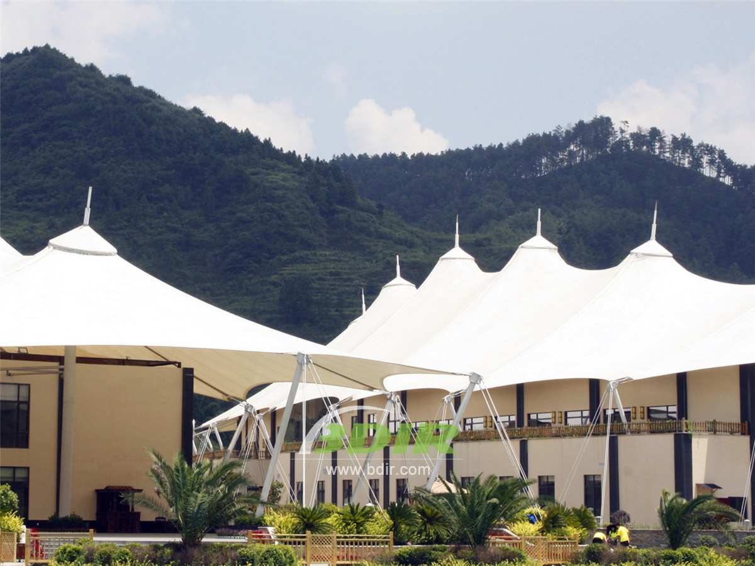
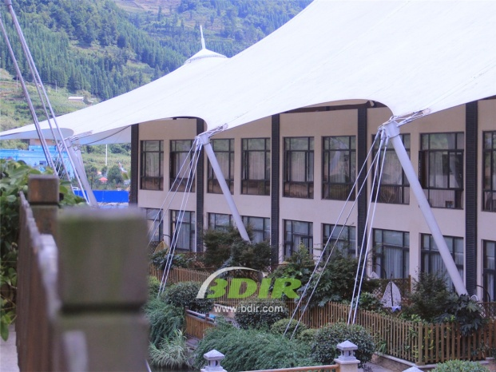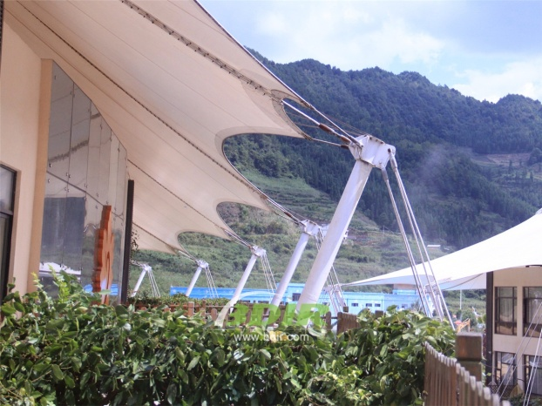
BDiR Inc. Design, manufacture, installation, maintenance Luxury safari tent resort, glamping tents, eco-lodges and resort tents at very reasonable prices. We ship canvas tents worldwide for all purposes. No matter where your tent or camp will be located in - be it on water, rocks, desert, sand, a grassy plain, tropical beach, ice field or in dense rainforest - we will ensure it is built to last.

