ECO Friendly Dome Tents Hotel | Patagonia Eco Camping Domes 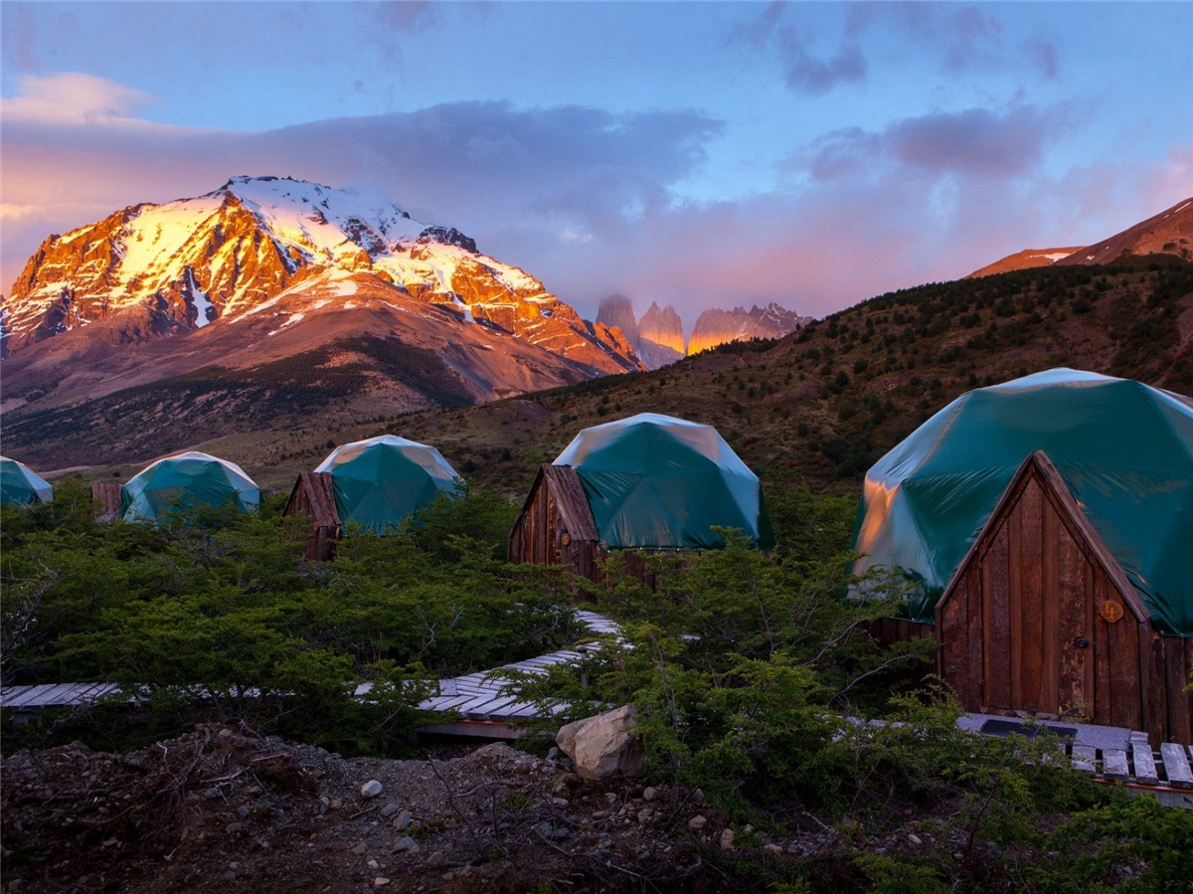
Product specifications:
• Diameter: 4.9 meters or 5.9 meters
• Base area: 20 square meters or 27.5 square meters
• Entrance: H 180cm x W 70cm
• Maximum height: 2.9 meters or 3.65 meters
• Quantity: 20 dome tents
Material:
• 950g/m2 Germany imported white PVC film material, 850 g/m2 Germany imported transparent PVC film material
• Windproof up to 80-100km/h, 100% fire retardant, waterproof and snowproof
• Galvanized steel pipe Q235, diameter 20*1.5mm
• Use stainless steel tube as frame material
• Configure insulation, wood burning stove, curtains

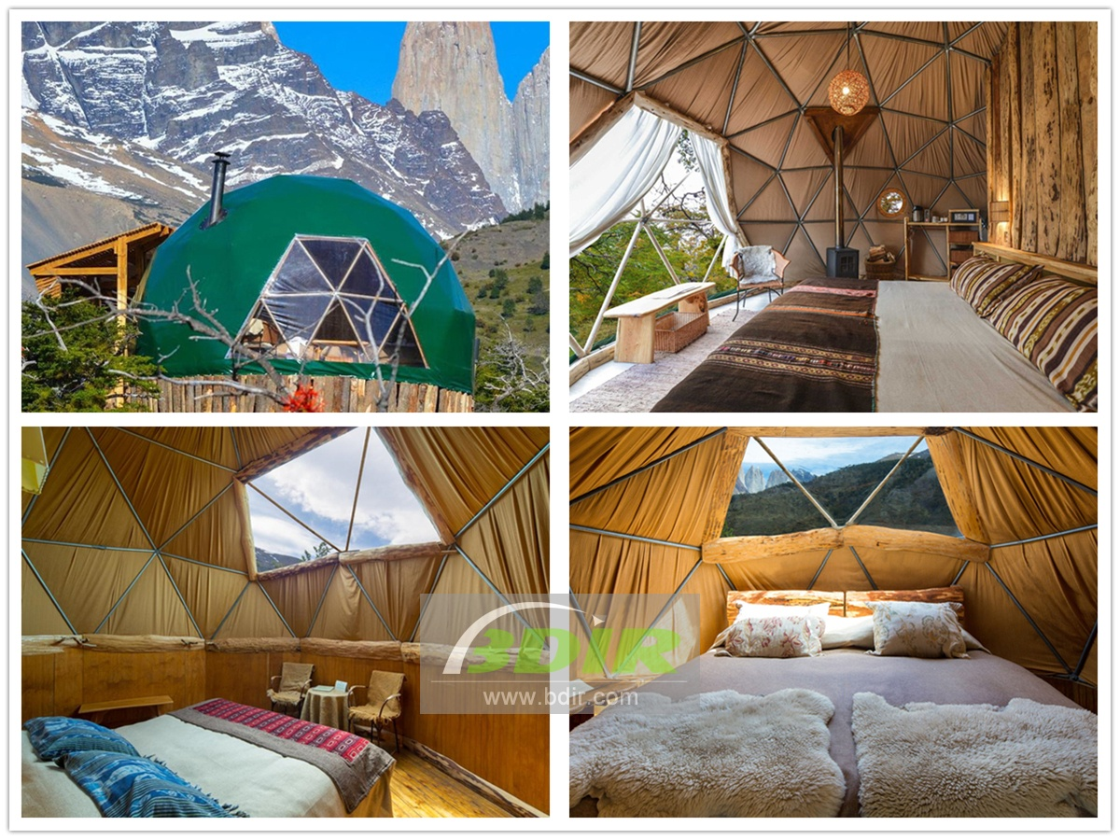

Take some time to explore this fragile paradise, enjoy hiking, and experience a variety of sports adventures, wildlife watching, and a night of harmony with nature in your own eco dome tent. Most importantly, we are 100% sustainable, which means you can relax and enjoy your trip without worrying about your impact on this fragile land.
The dome tent house adopts a combined galvanized steel structure frame, which can be safely and stably used in different terrains. The eco friendly geodesic dome tent can withstand winds of 8-10 level , it can carry rain and snow, and adapt to the temperature environment of -30° to 70°. The geodesic dome roof is made of ultra-light PVC, PVDF and other materials,which with good waterproof, UV-resistant, tear-resistant properties, as well as B1/M2 fire resistance. The interior of the geodome home is decorated with bedrooms, bathrooms, terraces and other areas, furniture, flooring, lighting and other facilities. You can also experience the comfort of a five-star hotel in the wild.
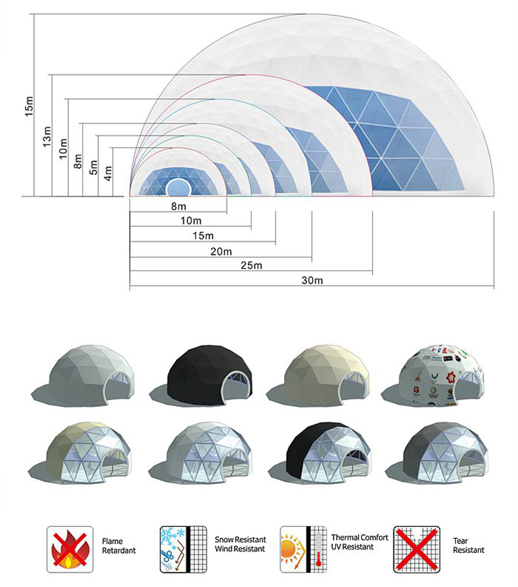
BDiR Inc. is a dome designer and manufacturer, which provides 5m - 100m best quality complete dome tents for living home, glamping tent house, camping pods, greenhouse, branding, product launches, commercial receptions, outdoor concerts and business annual celebrations, festival, performance, trade show booth, corporate events and conferences, product launches and promotions, Art installations, floating domes, igloo and rooftop lounges, movies, private parties, special occasions, etc.

