Eco Friendly Fabric Membrane Tent Structures Lodges In Desert Camping Resort
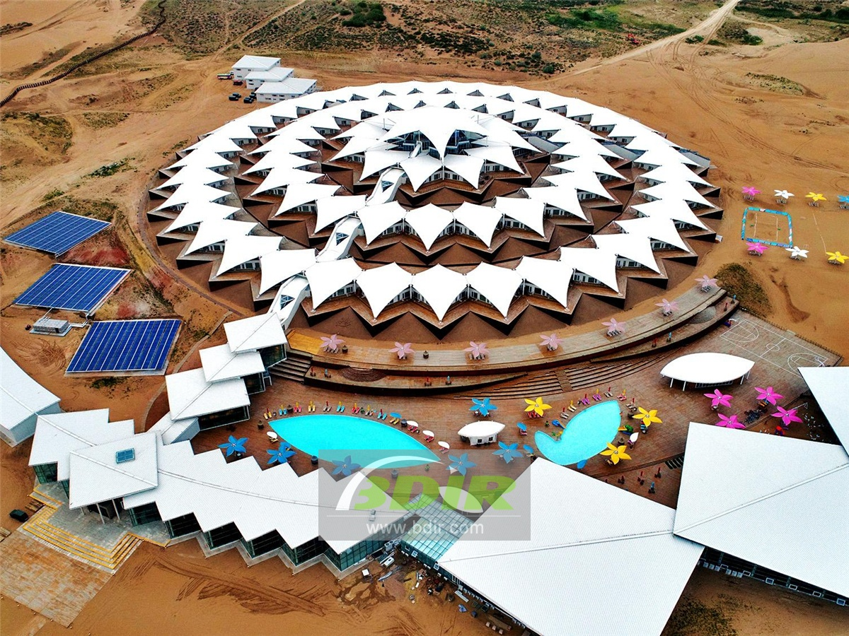
Xiangsha Bay is located the easternmost tip of the famous Kubuqi Desert in China. The scenic area is 24 square kilometers. It is located in the center of the “Golden Triangle” development zone in Hohhot, Baotou and Erdos. It is called “the gold button on the yellow belt of the Yellow River”.
Lotus Hotel is located in the Kubuqi Desert of Dalateqi, Erdos City, Inner Mongolia, 170 km from Hohhot and 650 km from Beijing. The Lotus tent Hotel on xiangsha bay Holiday Island is a green building without bricks, tiles, sand, stone, cement and steel. It maintains the original natural ecology of the desert as much as possible, which adopts a eco friendly and lightwight steel keel and tensile membrane structure system. The hotel has 383 sand-view tent rooms, tented family rooms and luxurious viewing tented house, most of which are made of wood.
The shape of the entire hotel is also like a blooming lotus flower. Lotus Holiday Island tent resort is a leisurely place with Buddhist culture. It is a place where you are happy, healthy and beautiful. It is like a ship in the desert, carrying the function of living, not only looks beautiful, but also the most important is environmental protection. At the same time, taking into account the functions of shading and wind protection, the concept of hotel design is not only about structure, but also deeply considers the internal space experience, and also takes desert culture as the theme.
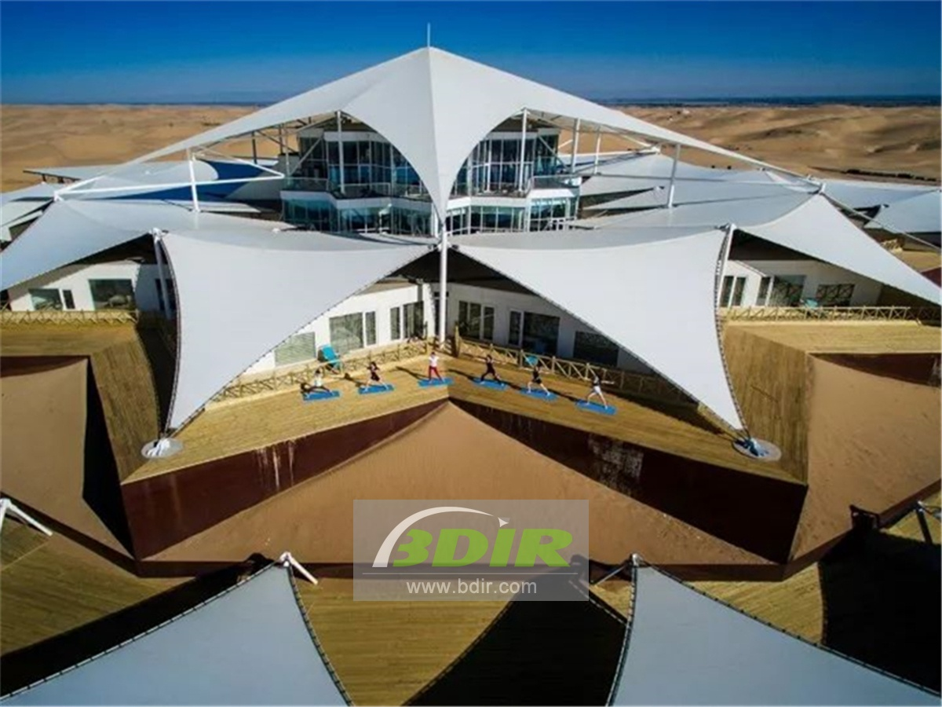
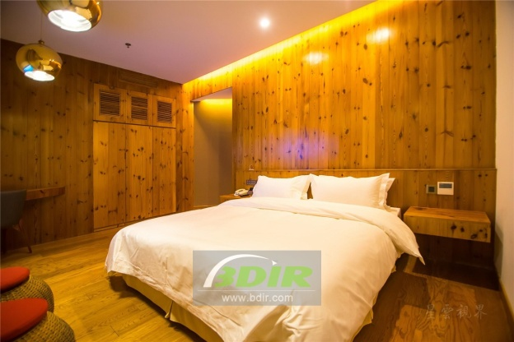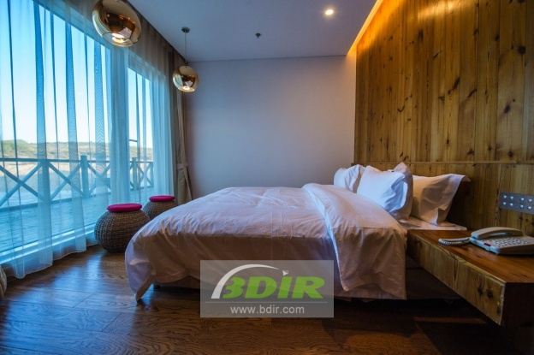
BDiR Inc. Design, manufacture, installation, maintenance Luxury safari tent resort, glamping tents, eco-lodges and resort tents at very reasonable prices. We ship canvas tents worldwide for all purposes. No matter where your tent or camp will be located in - be it on water, rocks, desert, sand, a grassy plain, tropical beach, ice field or in dense rainforest - we will ensure it is built to last.

