Five-Star Tent Hotel - Desert Camping Tent Resort – Eco-friendly Tented Camp
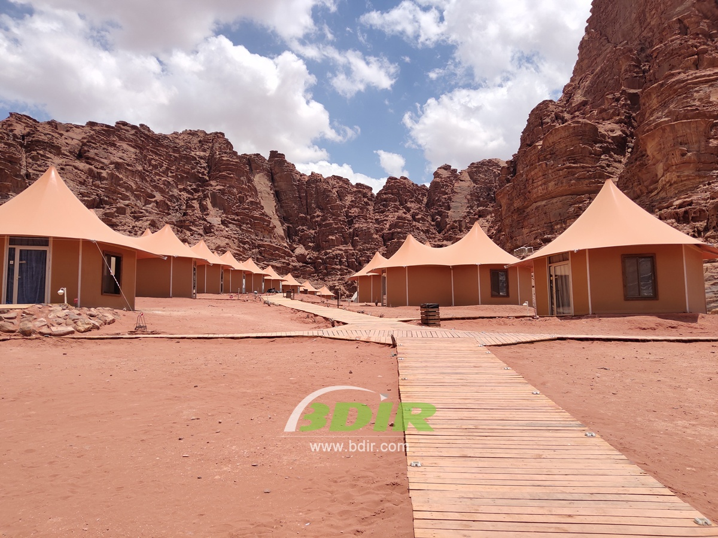
The desert has one of the most impressive landscapes in the world, but it's hard to explain its charm or sit on the sand dunes of the desert to watch the sunset. It's also difficult to share the emotions of seeing the infinitely long red sands. It's just a feeling of being interrupted by the wind and waves on the hot windy beach. However, in this magical environment, a Desert Camping Resort consisting of luxury tents, let you experience the desert style while still being comfortable and luxurious. Desert Resort Hotel according to the design layout, different styles of membrane structure tents are used for rooms, reception centers and restaurants, bars. The combination of the simple and simple decoration of the tent rooms and the five-star luxury rating decoration makes it an ideal place to explore and learn to love the desert. Desert tent hotel is very suitable for desert countries such as Oman, Saudi Arabia, United Arab Emirates, etc. The luxury desert camp is an ideal base for desert adventures. On the terrace of the tent lodge, enjoy the spectacular rugged mountains, endless dunes and crystal clear valleys.
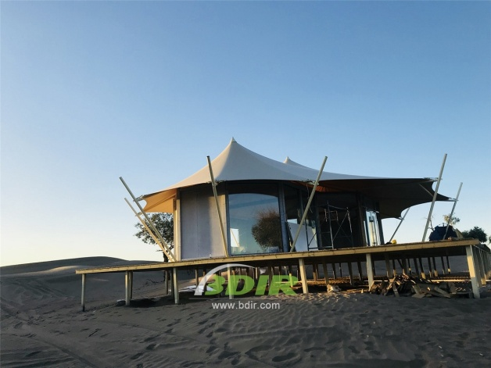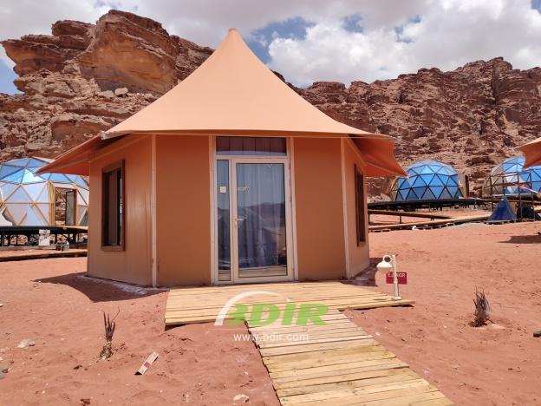
Enjoy the unique experience of riding a camel at sunset. After a long day of sand dunes and dune cycling on the golden & red sand beach, you can relax in the fully air-conditioned tent room and enjoy the luxurious en suite bathroom of the tent hotel. In the middle of the night, you can enjoy the magical nights and enjoy the traditional desert local cuisine. The desert camping tent camp will take you into an unparalleled world of luxury and comfort.
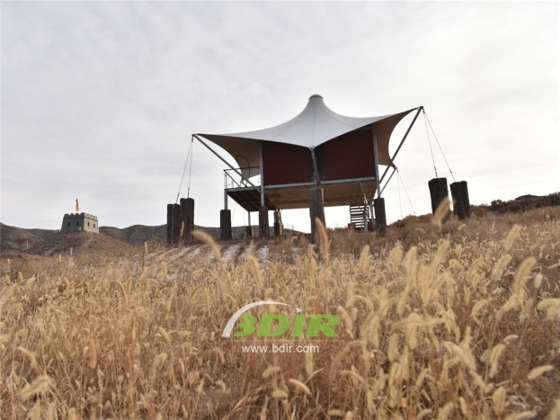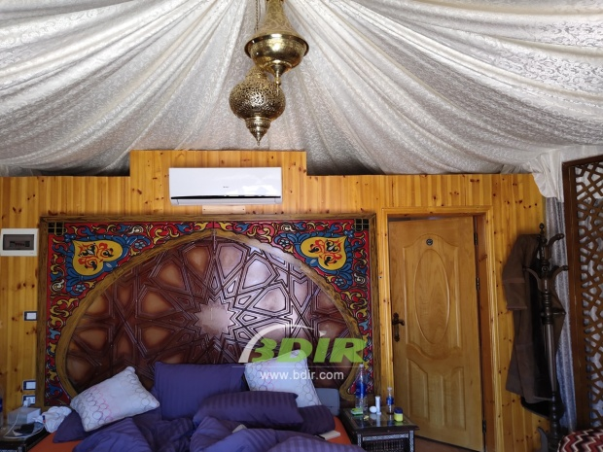
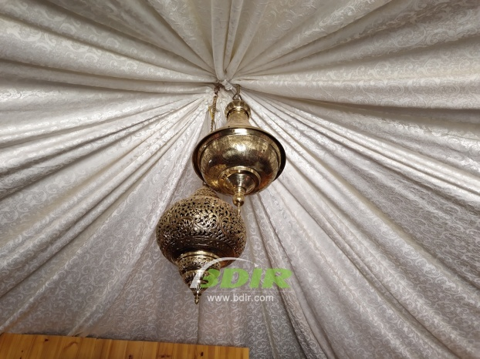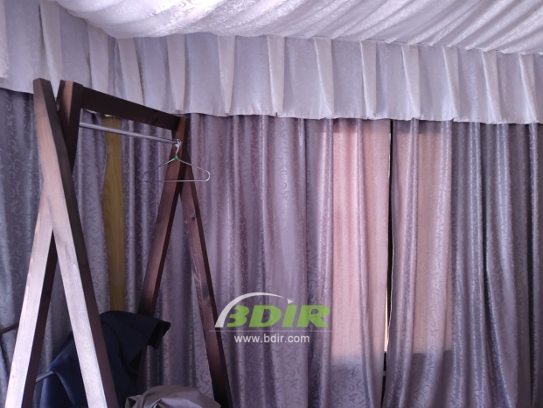
We offer wide range of Luxury canvas safari tents, glamping tents, eco-lodges and resort tents at very reasonable prices. We ship canvas tents worldwide for all purposes. No matter where your tent or camp will be located in - be it on water, rocks, desert, sand, a grassy plain, tropical beach, ice field or in dense rainforest - we will ensure it is built to last.

