Rain-forest Tented Camping Site with Luxury Tent Villas
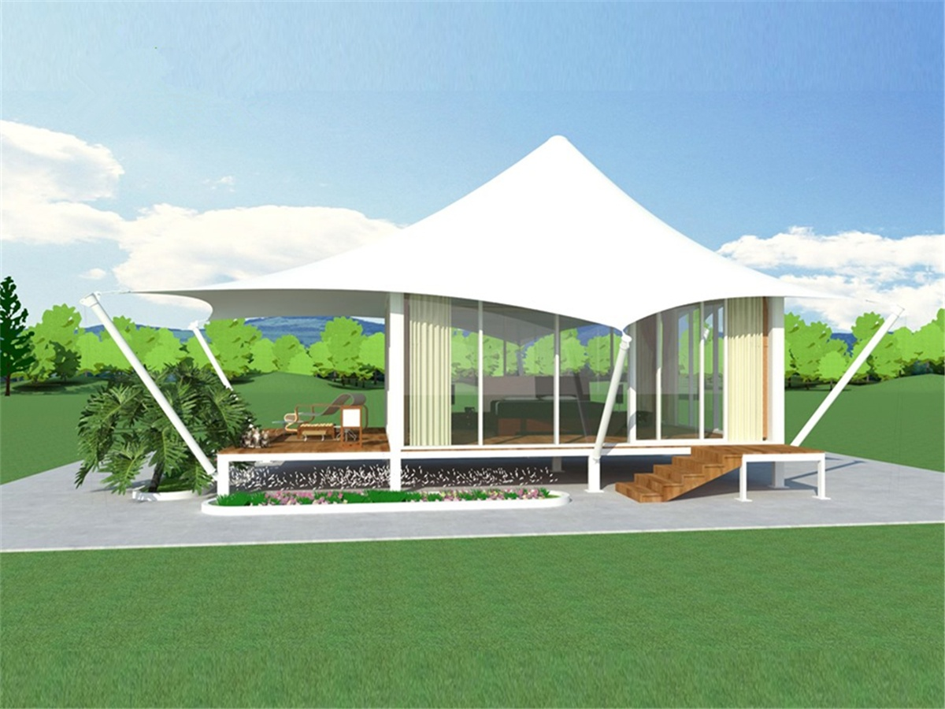
These tent apartments are located in the jungle. Each tent house decorated with individualized homes and colors, with a spacious space on the outdoor terrace, the original Primeval forest features are perfectly presented.
Each of the luxurious tent cabins is an exquisite piece of art, all decorated with distinctive themes and carefully selected works of art. All the accommodations offer great views: the sights of the Ruak River, the Burmese scenery and the mountains of Laos, or the lush jungle panorama and the golden triangle.
A quaint walkway guides you into the home tents, and pulls the ivory door handle and enters a spacious living area of 581 square feet (54 m²). On the outdoor deck of the luxury tent, there is a wooden hot tub custom-made for the Four Seasons hotel. Each tent is named as the local mountain tribes and flora and fauna, and which is decorated with individual colors and commensurate furniture to create a unique and beautifully decorated.

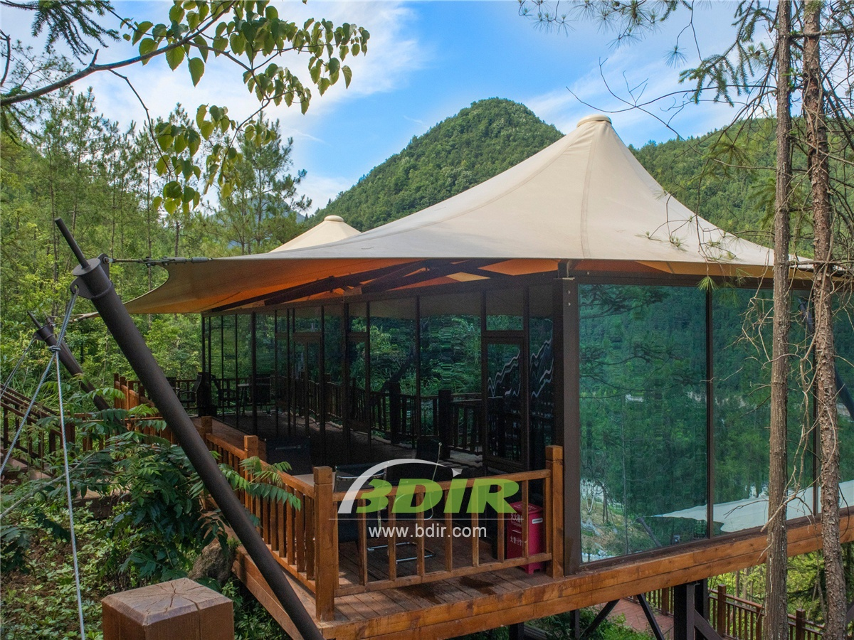
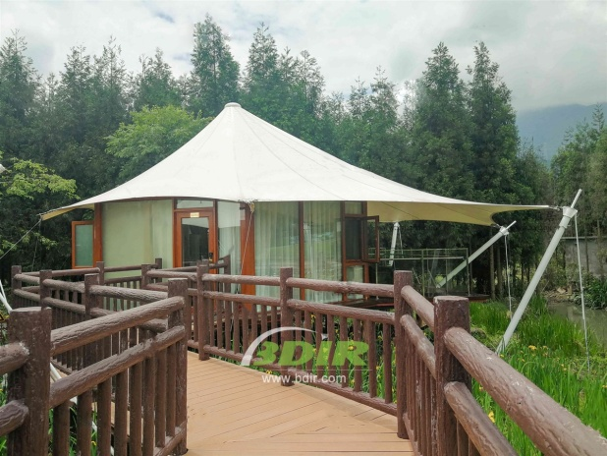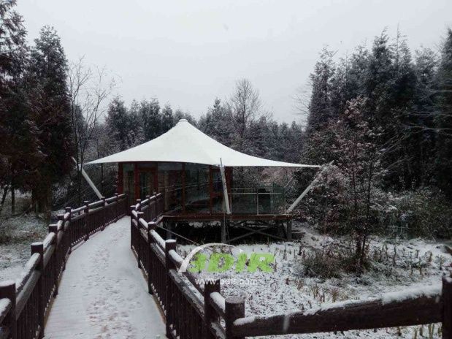
BDiR Inc. Design, manufacture, installation, maintenance Luxury safari tent resort, glamping tents, eco-lodges and resort tents at very reasonable prices. We ship canvas tents worldwide for all purposes. No matter where your tent or camp will be located in - be it on water, rocks, desert, sand, a grassy plain, tropical beach, ice field or in dense rainforest - we will ensure it is built to last.

