Glamping Geodesic Dome for Outdoor Stargazing
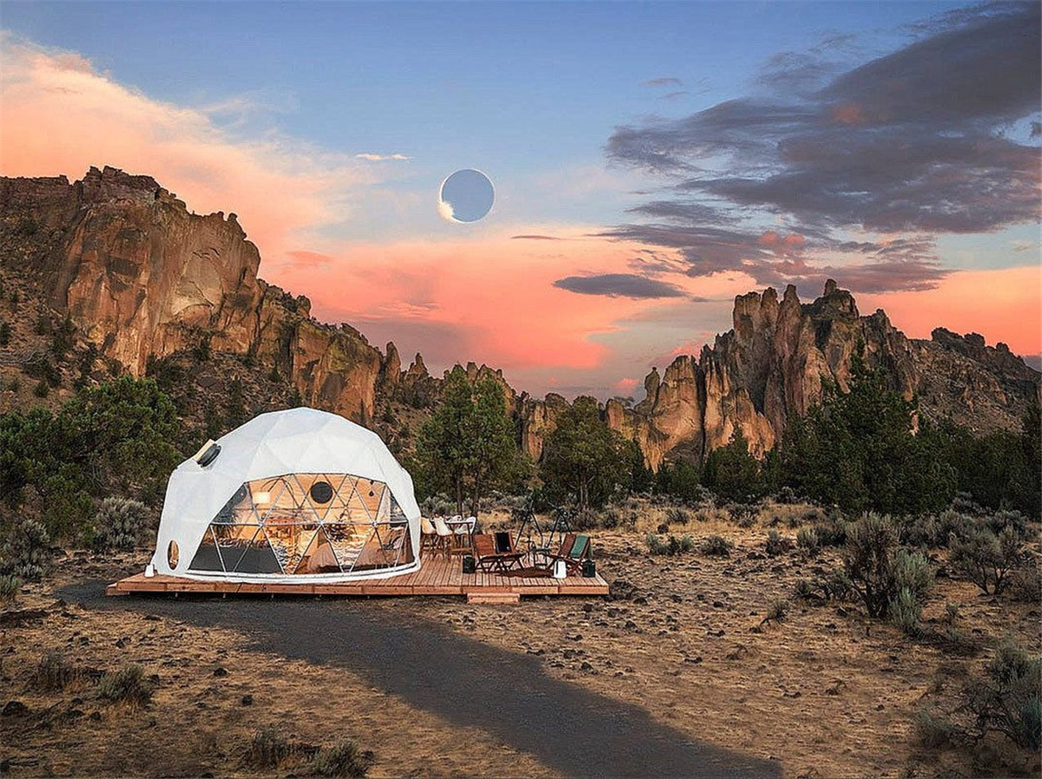
Product specifications:
• Diameter: 8 meters
• Base area: 50 square meters
• Entrance: H180cm x W70cm
• Maximum height: 400 cm
• Quantity: Three dome tents
• material: 950g/m2 imported PVC membrane material
• Windproof up to 80-100km/h, fire retardant, waterproof and snowproof
• Galvanized steel pipe Q235, diameter 20*1.5mm
• Using hot-dip galvanized 60 micron steel pipe as frame material
• With elastic cloth, insulation cotton to improve the insulation capacity of The tent
• Wooden viewing platform
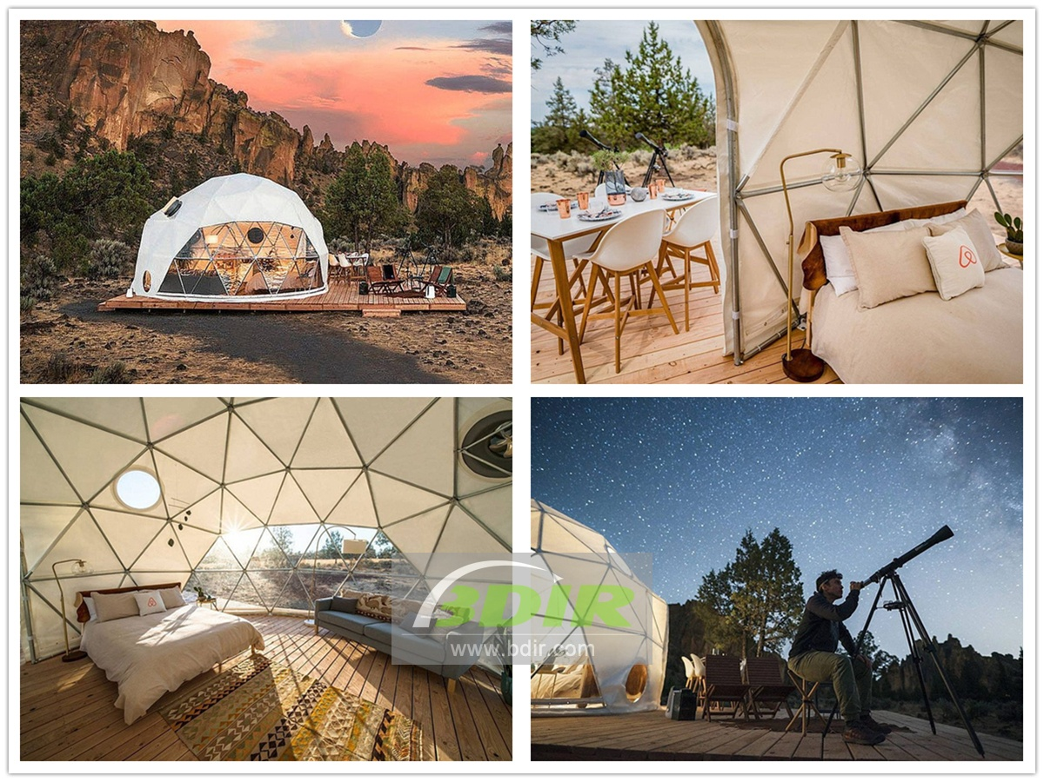
The geodesic dome pod has a room view deck and telescope. In order to provide the most amazing experience. It is a great way to observe the whole food and explore the wonders of the universe!
The main structure of spherical dome tent is used galvanized steel pipe as the frame material, and the surface is specially sprayed to greatly improve the anti-corrosion performance of the product. Even if it is placed outdoors, the service life can reach 10-20 years. The covered membrane of the geodesic tent is made of double-layer PVC fiber fabric, which has the characteristics of waterproof, flame retardant (DIN 4102 B1/M2), Anti-UV, tear resistance and snow resistance. The geodome tents can withstand an ambient temperature of about -30~70 °C, which is suitable for both high temperature and cold regions.

The unique structure of the spherical dome tent provides excellent safety. The geodesic dome tent can withstand the wind of 80-100km/h, even in the harsh weather such as heavy snow, wind and rain, even in the grass and beach. Soft foundations such as deserts and wilderness are also quite stable.
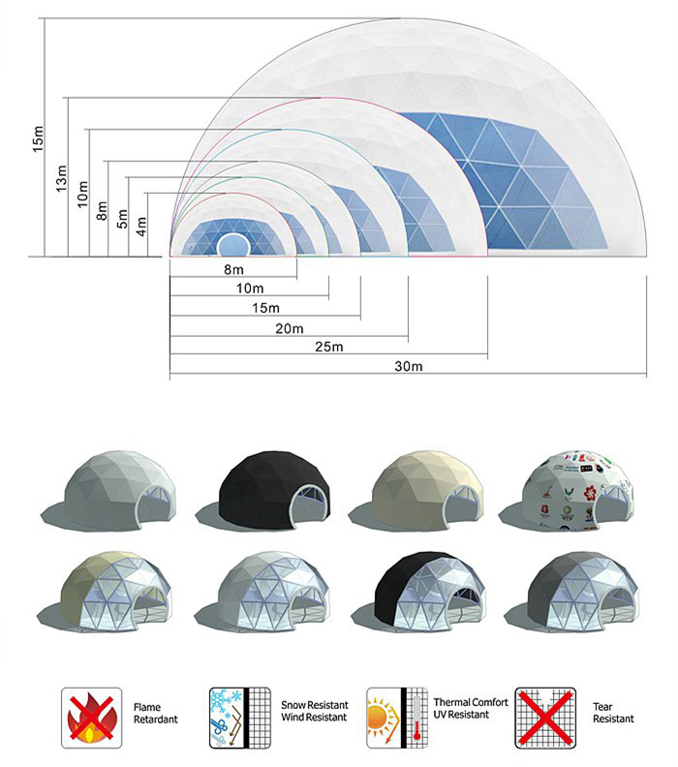
BDiR Inc. is a dome designer and manufacturer, which provides 5m - 100m best quality complete dome tents for living home, glamping tent house, camping pods, greenhouse, branding, product launches, commercial receptions, outdoor concerts and business annual celebrations, festival, performance, trade show booth, corporate events and conferences, product launches and promotions, Art installations, floating domes, igloo and rooftop lounges, movies, private parties, special occasions, etc.

