Safari Tent Camp with Eco-friendly Tented Lodges
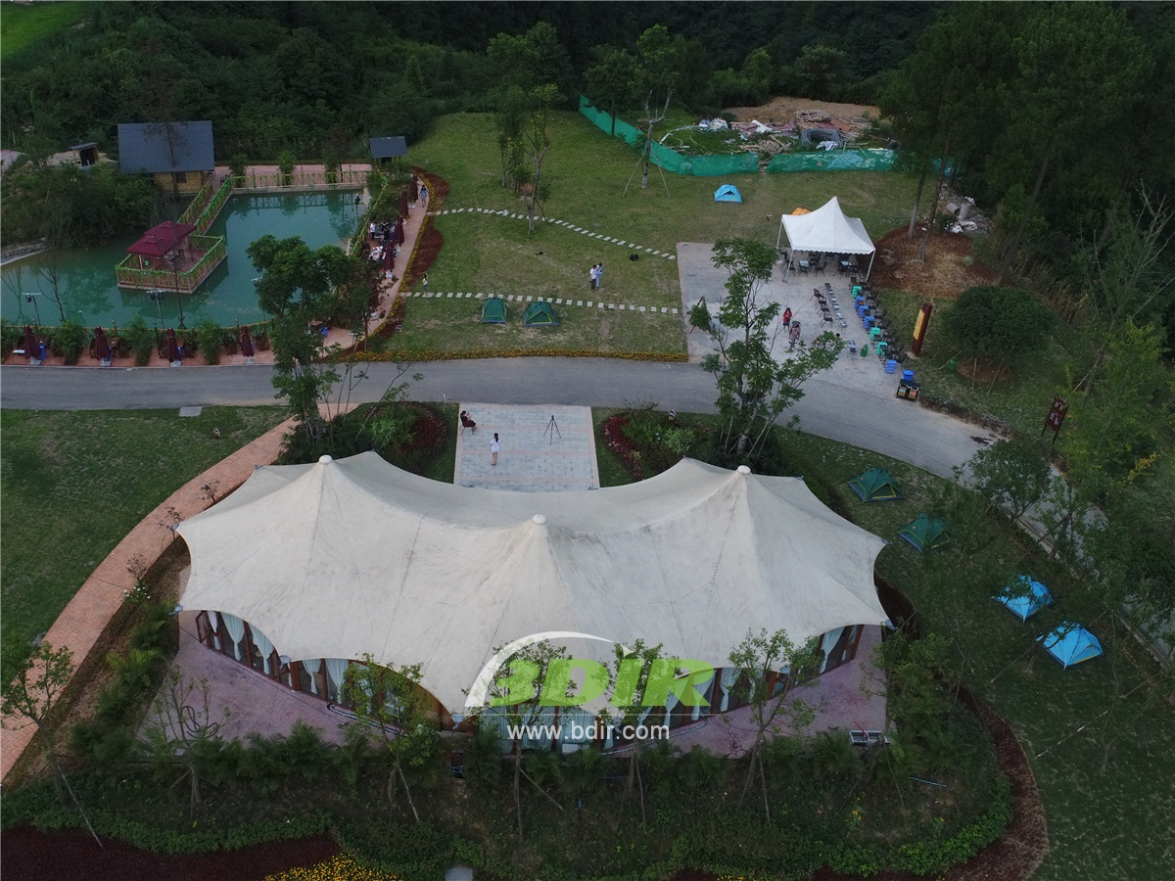
The Rain- forest Tented Camp are inspired by typical safari tent camps in Africa and Asia. The year-round forest Tented Camp is designed to fully immerse guests in the rainforest which experiences of areas around the equator, and displays 400 species of birds, tree sanctuaries and other wonders of the Arenal Rainforest. The 21 tents cabins are luxurious and environmentally friendly, which is blended with the surrounding natural environment, and it affirms the majesty of the rainforest. The most exciting part of the camp is a private tent lodge; the luxurious tent pods is located on the hill and offers a magnificent view of the Arenal Volcano.
Hotel Tent with luxury versatility design: Each of the luxury tent villas is 750 square feet and features an iconic plunge pool with natural hot springs, an outdoor shower, wooden floors and a covered four-poster bed. The tent has Comfortable and Spacious space, the bathroom is fitted with an oversized bathtub. The tent villa has a spacious outdoor living deck with the private plunge pool is filled with hot springs nearby.
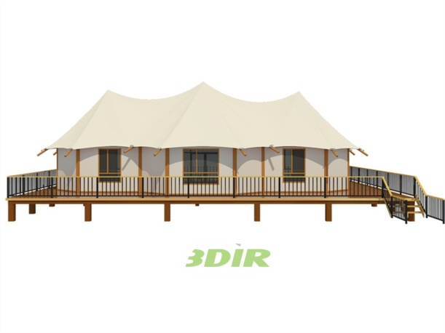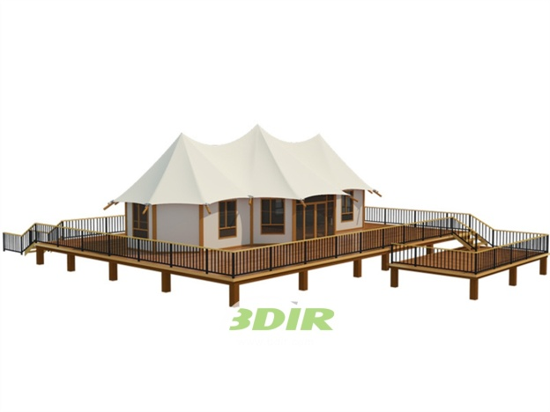
Eco-friendly structures design: The project's lightweight footprint approach, from tensile fabric roofing and canvas panelling to suspended floors, and the use of local and sustainable procurement of building materials,which is designed to be fully functional Eco-friendly resort.
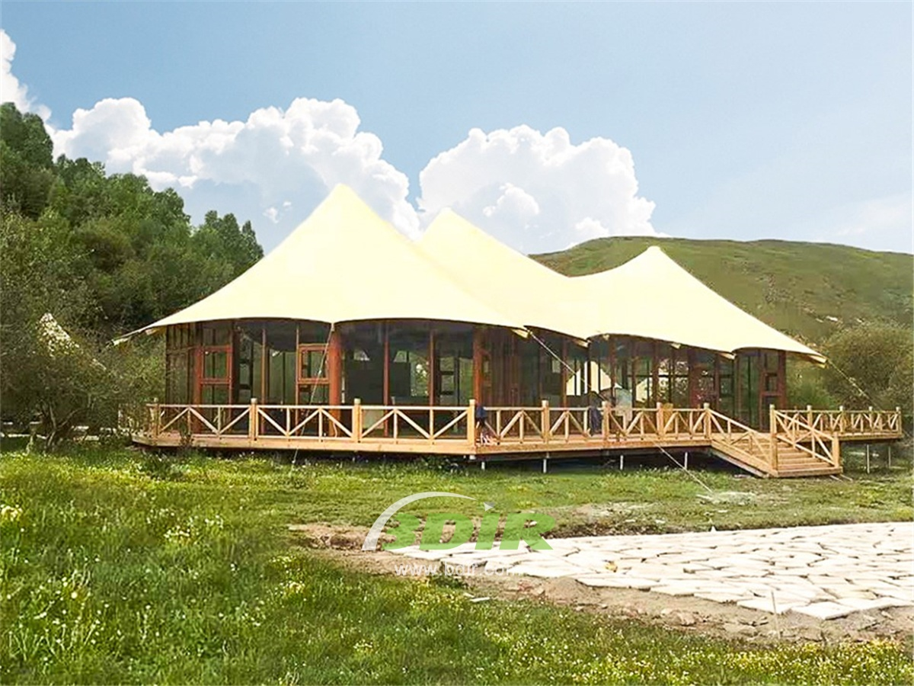
BDiR Inc. Design, manufacture, installation, maintenance Luxury safari tent resort, glamping tents, eco-lodges and resort tents at very reasonable prices. We ship canvas tents worldwide for all purposes. No matter where your tent or camp will be located in - be it on water, rocks, desert, sand, a grassy plain, tropical beach, ice field or in dense rainforest - we will ensure it is built to last.

