Monteverde Glamping unique experience with 6 Geodesic Domes Tent Pods 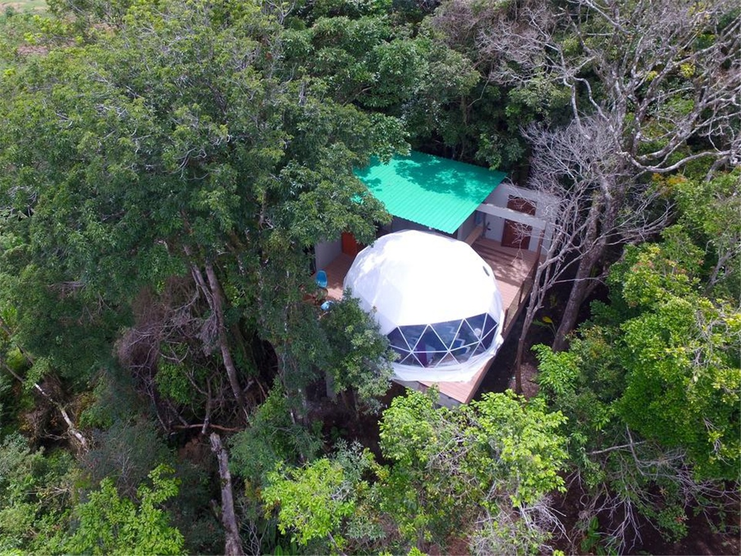
Product specifications:
• Diameter: 3*7 meters
• Base area: 40 square meters
• Entrance: height 180cm x width 70cm
• Maximum height: 3.5 meters
• Quantity: 6 dome tents
Material:
• 950g/m2 Germany imported white PVC film material, 850 g/m2 Germany imported transparent PVC film material
• Windproof up to 80-100km/h, 100% fire retardant, waterproof and snowproof
• Galvanized steel pipe Q235, diameter 20*1.5mm
• Use stainless steel tube as frame material
• Configure insulation, wood burning stove, curtains

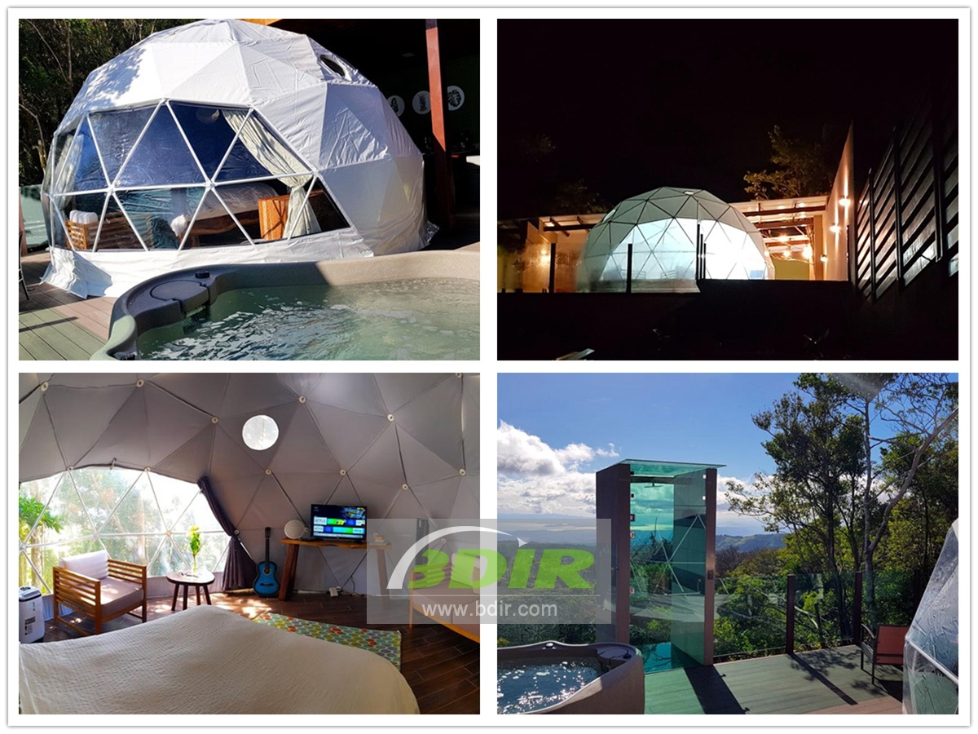
Spending an imaginary adventure in the luxurious dome tent cabins, we have 6 different luxury domes house with private outdoor kitchens and luxurious bathrooms. An elevated deck is surrounded by nature. Some domes room units have a hot tub and a children’s playground.
Some of the dome lodges have a garden, dining area and balcony. There is also an outdoor kitchen with a microwave, toaster and fridge, as well as a stovetop and coffee machine. Each dome tent room has a private bathroom with a shower and towels are provided.
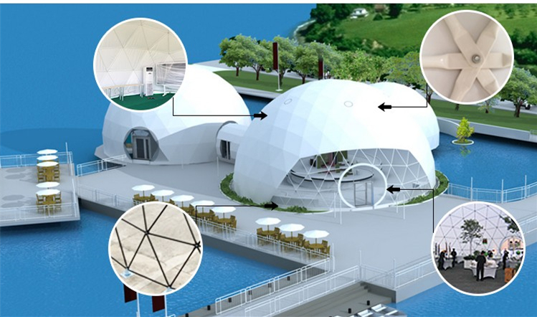
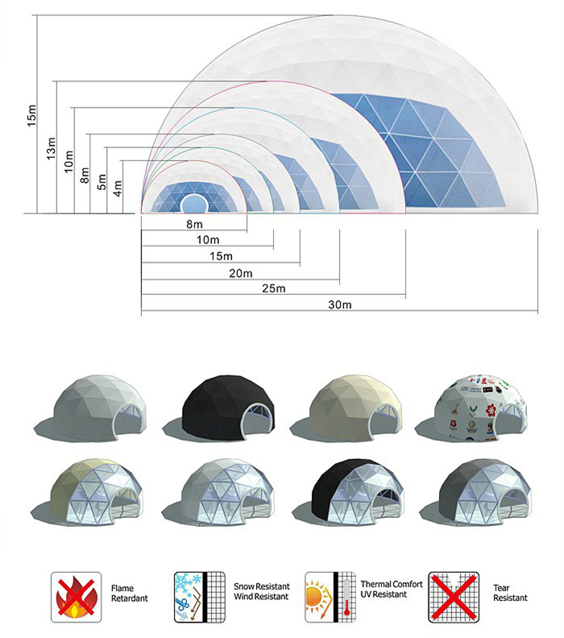
BDiR Inc. is a dome designer and manufacturer, which provides 5m - 100m best quality complete dome tents for living home, glamping tent house, camping pods, greenhouse, branding, product launches, commercial receptions, outdoor concerts and business annual celebrations, festival, performance, trade show booth, corporate events and conferences, product launches and promotions, Art installations, floating domes, igloo and rooftop lounges, movies, private parties, special occasions, etc.

