Oman Most Luxurious Iconic Desert Tent Resort
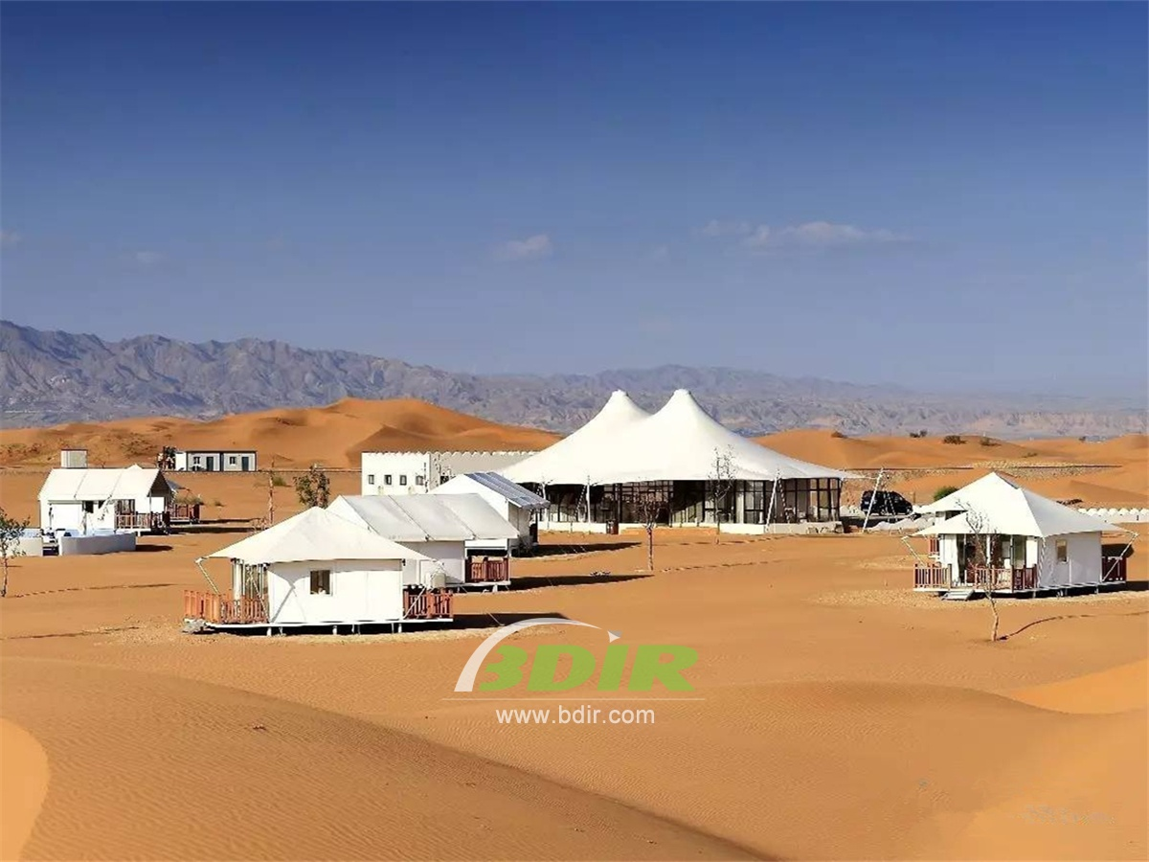
Desert Resort Tent Design & Equipped with affluent and ancient local decoration to make your stay more enjoyable. These iconic desert resorts are filled with luxurious tents, which includes a palace, ultra-luxurious bedrooms, interior design and individually controlled air conditioner throughout. Which makes accommodation is more comfortable. Staying in our luxurious tent house, these houses are designed as palaces and decorated for every whimsy of your wealth. Rich plush interiors, satin draped curtains and large size beds just One of the highlights.
The color of the tent house is integrated with the color of the dunes!
The tent hotel offers three types luxurious tent suites, each tent cabins are decorated with gold plating cultural, original oil lamps, kaleidoscope embroidered carpets and bedspreads. You will experience a refreshing morning, the sun shining through the glass window, with slightly draped satin curtains.

- Each luxury tent has a total area of 39 square meters, which is independent and spacious, and provides you with a separate seating area, a complete private bathroom and a luxurious environment. . . where is perfect for couples, singles or families Look for quality time throughout your stay.
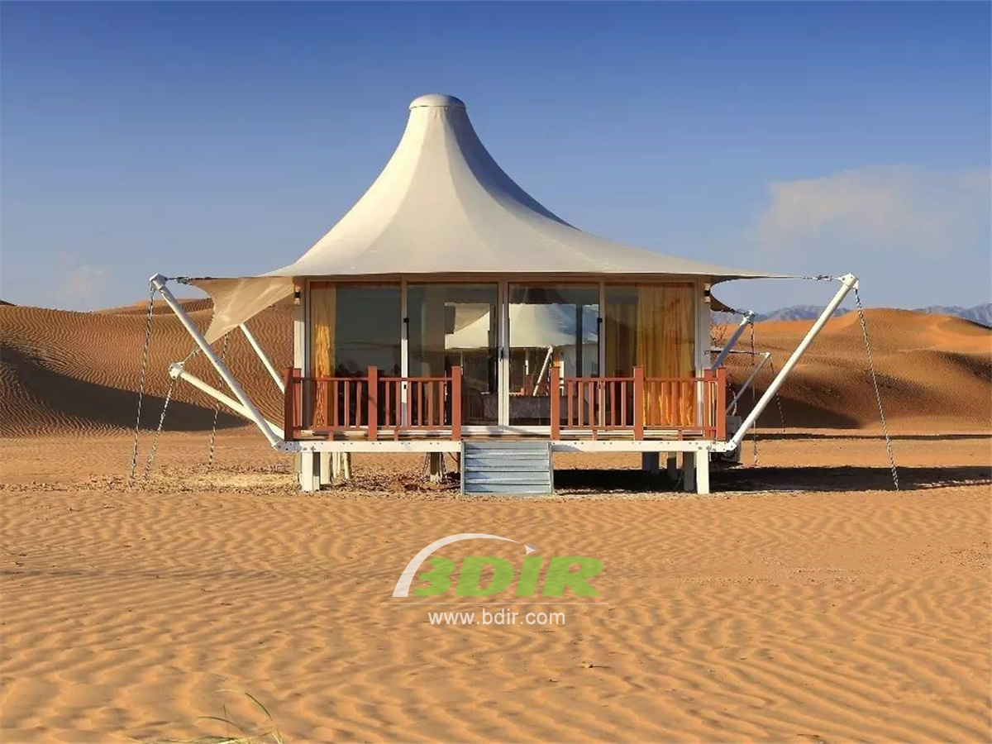

- Suite Tent is with a total area of 85 square meters which features a common entrance foyer that leads to two separate tent for luxury bedrooms, each with a private entrance, flat-screen TV, which individually controlled air conditioner and full en suite bathroom, as well as other modern travelers. Comfortable facilities. All suite tents also have a private patio area where you can enjoy cool night air and spectacular views.
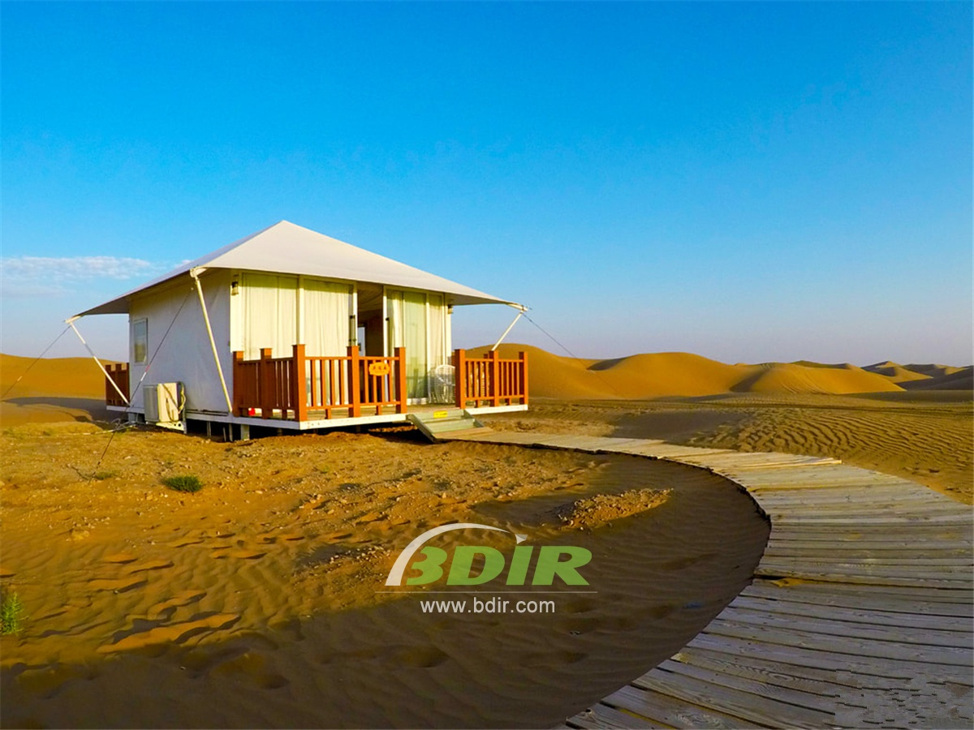
3. Royal tent, with a total area of 138 square meters, which is almost like the four tents. There is a large foyer at the entrance to greet you, it takes you into the luxurious living room or one of the two bedrooms (one with a king-size bed and two with two single beds) - three tents Each comes with TV, fully equipped bathroom, individually controlled air conditioning.
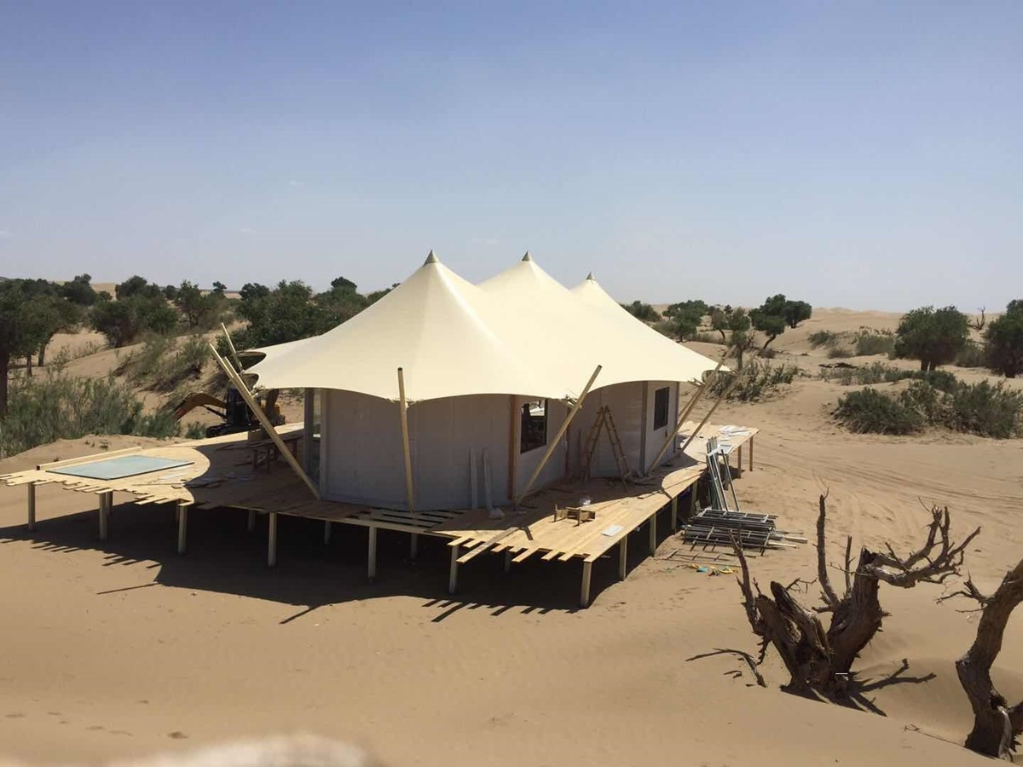
We offer wide range of Luxury canvas safari tents, glamping tents, eco-lodges and resort tents at very reasonable prices. We ship canvas tents worldwide for all purposes. No matter where your tent or camp will be located in - be it on water, rocks, desert, sand, a grassy plain, tropical beach, ice field or in dense rainforest - we will ensure it is built to last.

