PVDF Fabric Membrane Structure Tent House For Luxury Jungle Camping
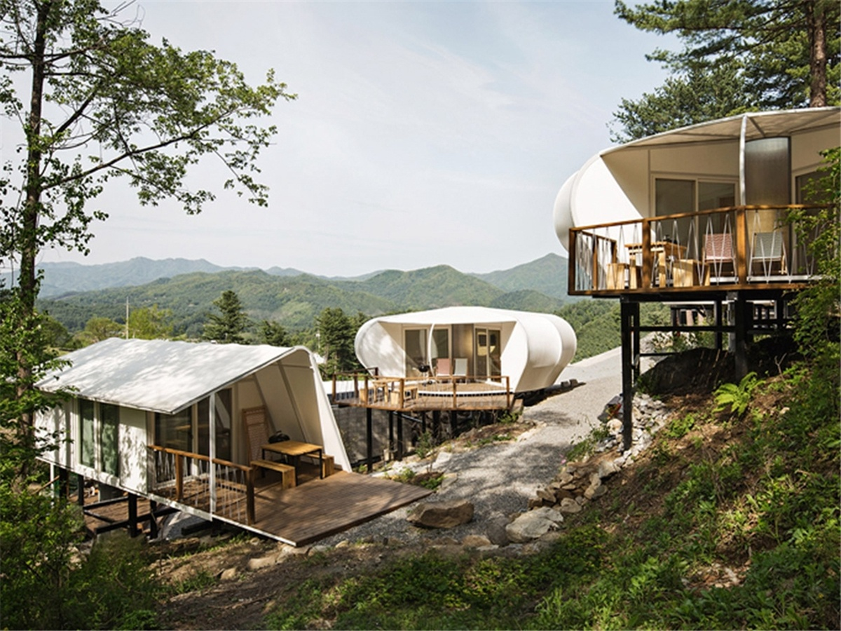
The glamping structure camping site is located in the holiday parks on the outskirts of city, which is famous for its botanical gardens, pine forests and mountainous Views.

The tent campsite,which retains and celebrates its natural features, while providing modern facilities and comfortable accommodation for those seeking to escape the city. When people visit the camp, they should experience nature first and should not be disturbed by the nature of destruction.

The glamping tent camp to create an opportunity for people to have a chance to experience nature more closely, while providing a uniquely designed building and comfortable venue: a place where nature, ecological value, comfort and modern design are balanced.
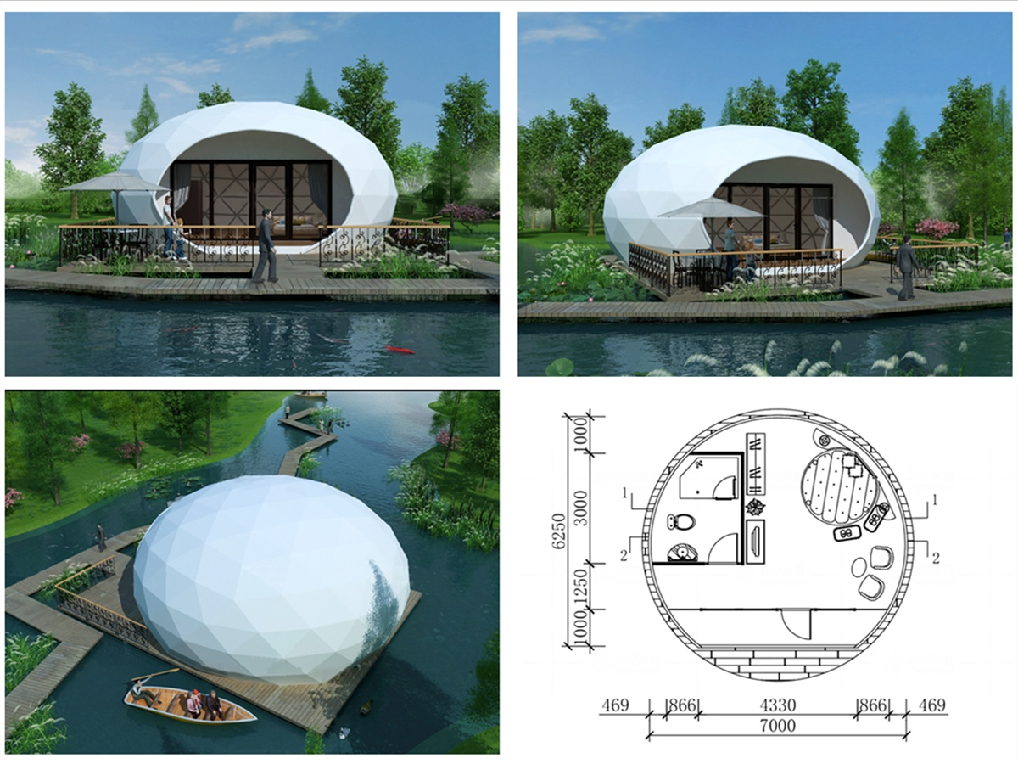

For the tented campsites, the architect introduced two types of dwelling units, called Rock Flower and Dynamic Triangle, which are made of a metal frame

that is covered on a protective film. The round windows at the top of the Rock Flower home are filled with natural light and offer views of the surrounding treetops. Each unit has a covered balcony facing the adjacent forest. The Dynamic Triangle has an asymmetrical sloping roof canopy that surrounds the living area and extends to the outdoor dining space on the deck. The translucent nature of the outer surface film of the sunshade causes them to glow like a lantern when illuminated from the inside at night.
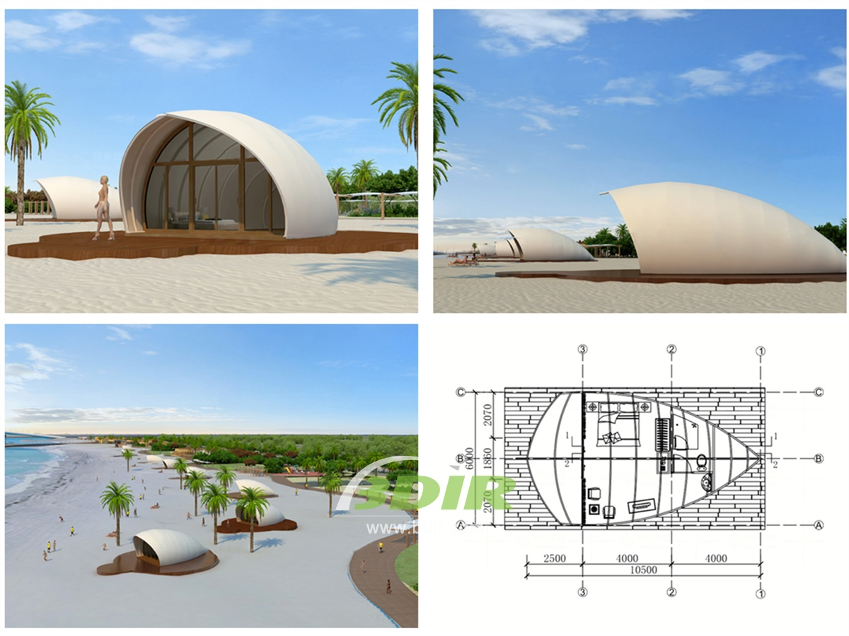
BDiR Inc. Design, manufacture, installation, maintenance Luxury safari tent resort, glamping tents, eco-lodges and resort tents at very reasonable prices. We ship canvas tents worldwide for all purposes. No matter where your tent or camp will be located in - be it on water, rocks, desert, sand, a grassy plain, tropical beach, ice field or in dense rainforest - we will ensure it is built to last.

