Island Tented Resort with 36 Fabric Structures Tent Pool Villas – Thailand
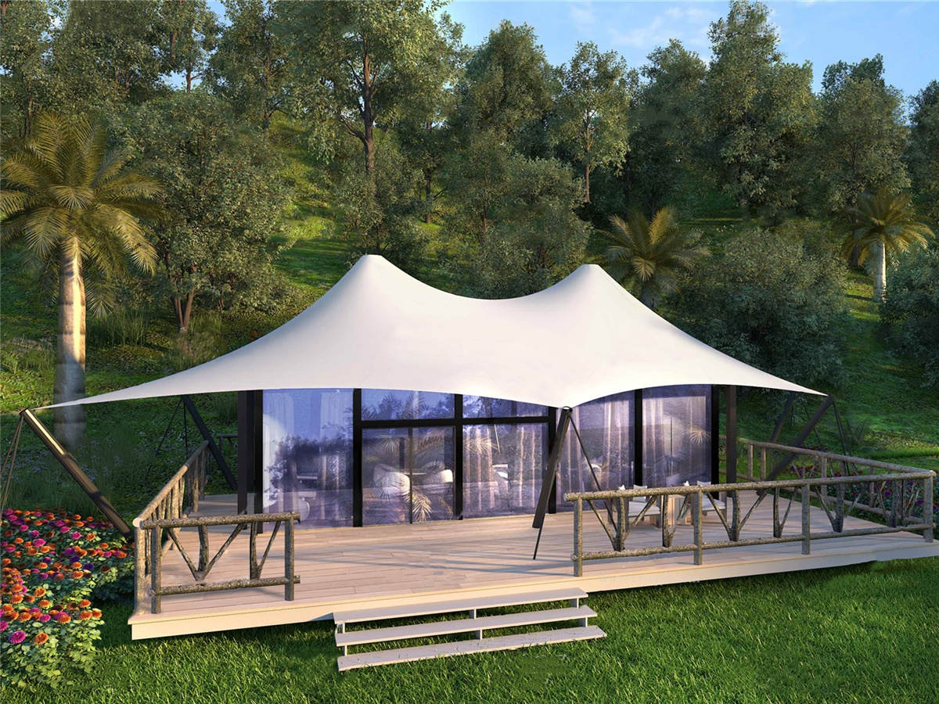
An unspoiled island, uninhabited jungles, pristine beaches and local fishing villages. The number of different ecosystems which was combined with the sparsely populated and relatively unpolluted environment on the island means that The island supports a diverse range of life. The island's ocean is full of marine life, while the inland is home to wild animals, lush plants and exotic butterflies.
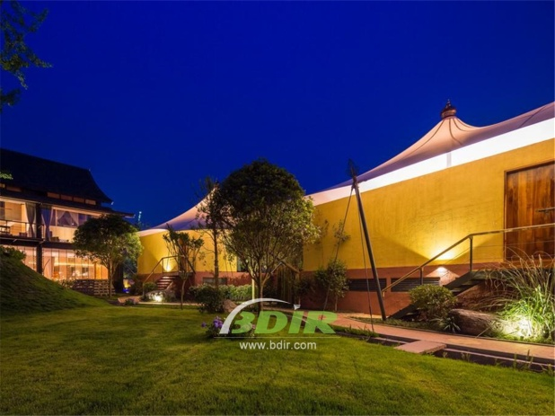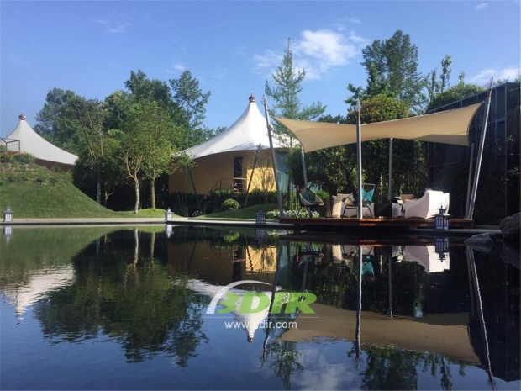
The tented resort offers unparalleled luxury and eco-friendly design tent house and an unforgettable authentic eco-tourmis experience. The tent resort is the ultimate luxury, imaginative. In the resort with “smart luxury” design, international standard resort facilities are integrated with nature. Most of the resort's tent buildings are based on local, beach-style buildings are noble and atmospheric, and the details are simple but not simple.
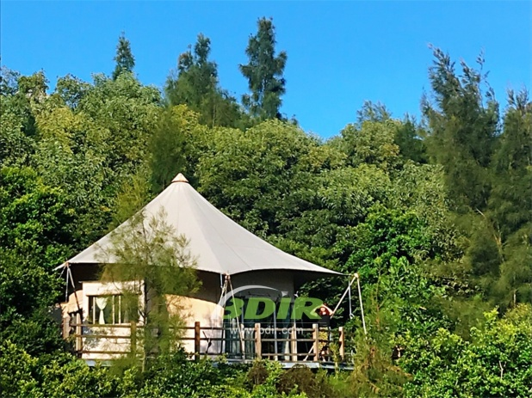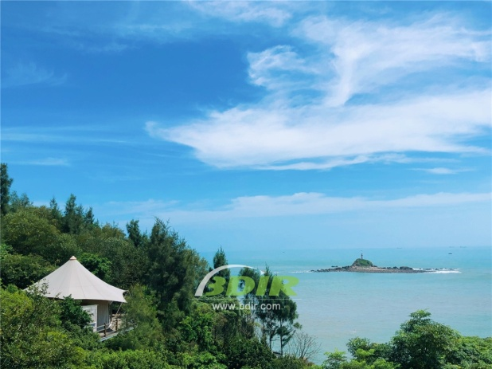
The tented resort has 36 spacious tent pool villas set on idyllic beaches or sunny hillsides in the rainforest. Incredible chic furniture is made from the finest sustainable materials, and every tent villa in the resort offers electric cars and bicycles that you can use to easily travel through the island's attractions.
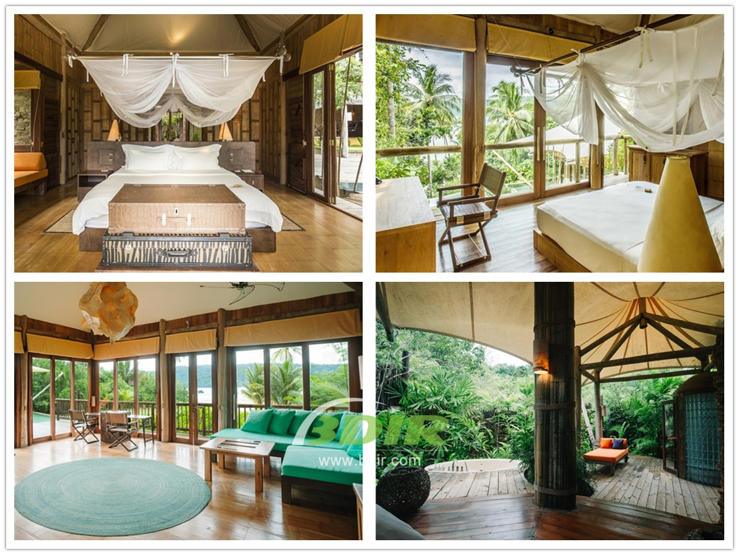
BDiR Inc. Design, manufacture, installation, maintenance Luxury safari tent resort, glamping tents, eco-lodges and resort tents at very reasonable prices. We ship canvas tents worldwide for all purposes. No matter where your tent or camp will be located in - be it on water, rocks, desert, sand, a grassy plain, tropical beach, ice field or in dense rainforest - we will ensure it is built to last.

