Yoga Domes | Geodesic Dome Shelter | Sport Dome Tent
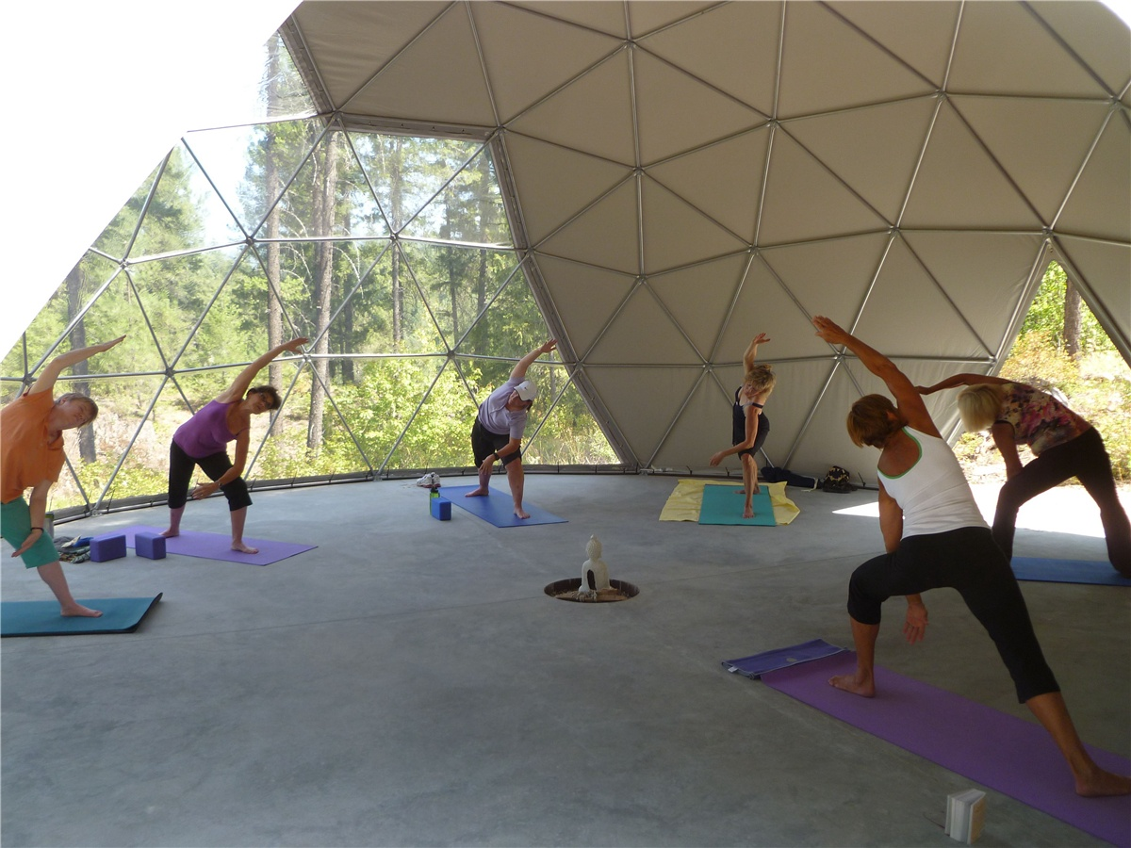
Product specifications:
• Diameter: 13.5 meters
• Base area: 145 square meters
• Maximum height: 6.5 meters
• Quantity: 1 geodetic yoga dome
Material:
• 950g/m2 Germany imported white PVC film material, 850 g/m2 Germany imported transparent PVC film material
• Windproof up to 80-100km/h, 100% fire retardant, waterproof and snowproof
• Galvanized steel pipe Q235, diameter 25*1.5mm
• Using stainless steel tube as frame material
• Configure wooden floors
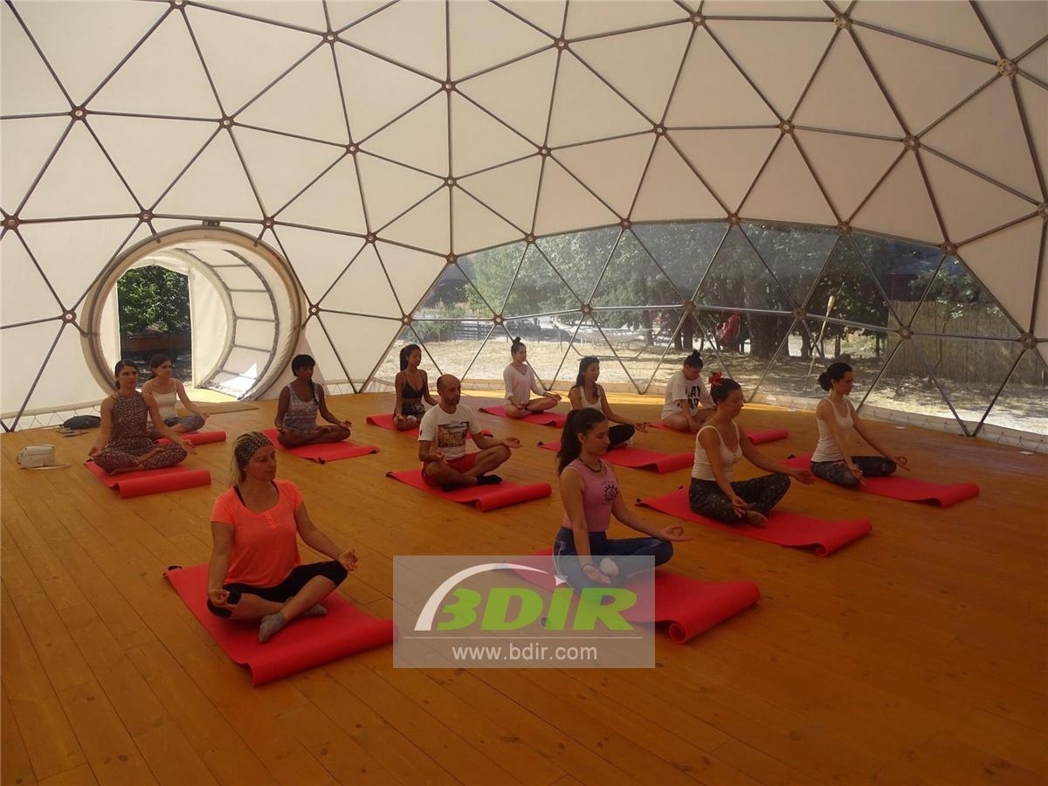

Many therapists use domes, because they believe that geometry helps reorganize body cells, thereby improving health and creativity. The geodesic dome can eliminate stray electromagnetic waves by grounding the metal structure to the ground. The final geometry created is the sphere - atoms, molecules, earth, sun, stars, moon, etc. All spheres mathematically produce a singularity that produces static at the center of all wave cancellations - the practice of Bindu points in ancient meditation. Practicing yoga is a revolutionary act that brings us into a state of inner freedom and peace. Through yoga practice, we become healthier and discover our strength and source of inspiration.
Grid dome tents use ultra-light PVC membranes and a stable steel frame structure, which makes it the lightest, strongest and most cost-effective structure ever. They can cover more space without internal support than any other enclosure known to us.
Within the geodesic dome tent, we develop the ability to bring the mind back to the land of love, which transforms our perception so that we can see and experience what connects us all. When we come together and share the practice, the effect is magnified.
Whether as an extra space or as a stand-alone lightweight dome structure, the geodesic domes we design, manufacture, and install are used to develop the most diverse types of activities. In public spaces, businesses or private homes, the geodesic domes can be libraries, entertainment venues, sports activity rooms or spaces dedicated to meditation and yoga practice.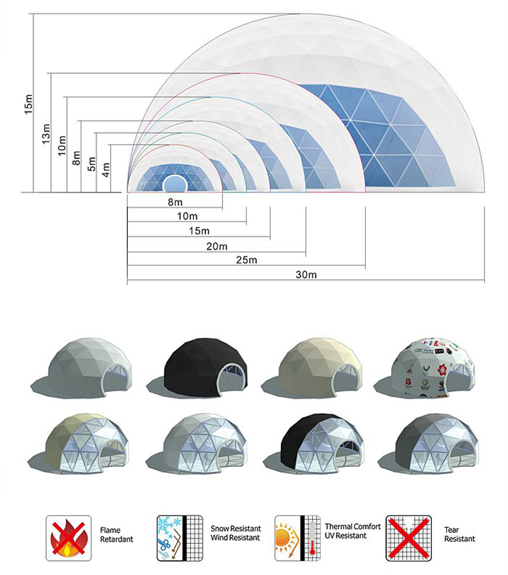
BDiR Inc. is a dome designer and manufacturer, which provides 5m - 100m best quality complete dome tents for living home, glamping tent house, camping pods, greenhouse, branding, product launches, commercial receptions, outdoor concerts and business annual celebrations, festival, performance, trade show booth, corporate events and conferences, product launches and promotions, Art installations, floating domes, igloo and rooftop lounges, movies, private parties, special occasions, etc.
