Glamping Tent Structures Covering With Double PVDF Fabric Membrane
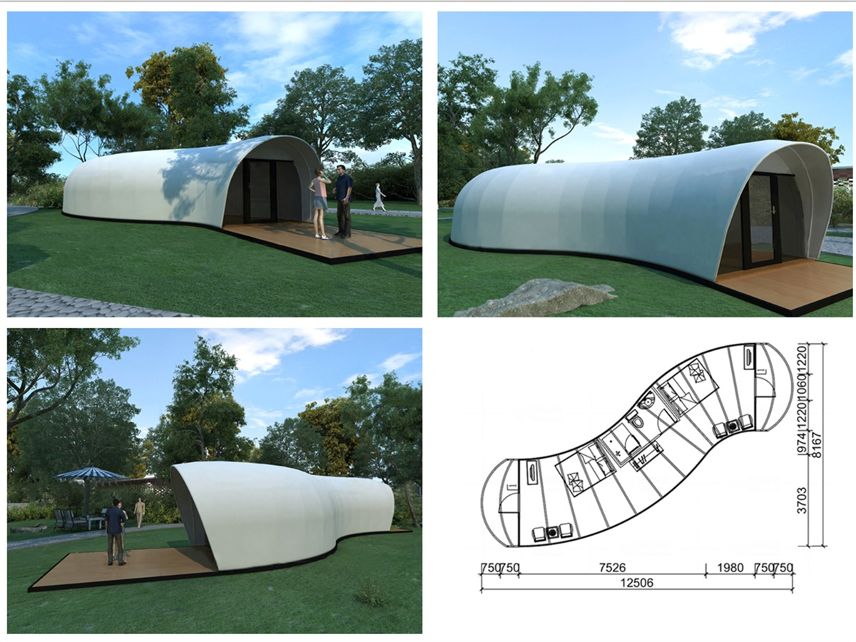
Camping or charming camping – an exciting place that is close to nature, ecological value, comfort and modern design has become increasingly popular. This approach combines the traditional outdoor camper's affinity with hotel amenities,which includes comfortable bedding, bathrooms and kitchens. The custom semi-permanent tent structure adds a design-conscious upgrade to traditional camping tents. This membrane-structured tent gives people the opportunity to experience nature and enjoy a unique design and the comfort of a five-star hotel.
Two models of open-air tents were designed based on species prototypes in nature. The Stacking Doughnut tent is inspired by pebbles and has a wedge-shaped deck between the bedroom and the living room. Modular Flow tents are designed for expandable construction by juxtaposed modular floor panels. The Modular Flow tent is a slightly oscillating tube whose sleep and rest areas are separated by internal partitions. The shape consists of a series of identical modules that are arranged from front to back to produce a curve.
Both models feature a white double-layer PVDF film that is UV-resistant, waterproof and fire resistant. The double skin is resistant to extreme weather in the four seasons. For the complex geometry of the casing, the computer animated surface plan is drawn with a 2D cutter and welded with high frequency technology, which provides absolute water tightness. Carefully consider the shape and location of the structure to create an aesthetic in day and night. The stainless steel frame is on site and the structure is simply bolted in place. The deck is made of wood and the interior floor is carpeted with Swedish cream textile flooring.
BDiR Inc. Design, manufacture, installation, maintenance Luxury safari tent resort, glamping tents, eco-lodges and resort tents at very reasonable prices. We ship canvas tents worldwide for all purposes. No matter where your tent or camp will be located in - be it on water, rocks, desert, sand, a grassy plain, tropical beach, ice field or in dense rainforest - we will ensure it is built to last.

