Tensile Structure for Badminton Court | Badminton Court Covers, Roofing Shade

Membrane Material | PVC / PVDF / PTFE / ETFE
Material Brand | Ferrari, Heytex, Duraskin, SATTLER, Mehler, Sioen, etc.
Fabric Color | White or Customized
Shape | Customized (Arc, Barrel Vault, Hypar, Cone, Dome, Umbrella, etc.)
Structure | Q235 steel, Hot Dip Galvanized
Size | Customized
Warranty Time | 10-35 years
Transport Package | Standard Export Sea-Worthy Packing
Delivery Time | About 30 Days after confirm deposit
Certification | ISO9001, MSDS, CE, BV, TUV, SGS
Place of Origin | Shenzhen, China

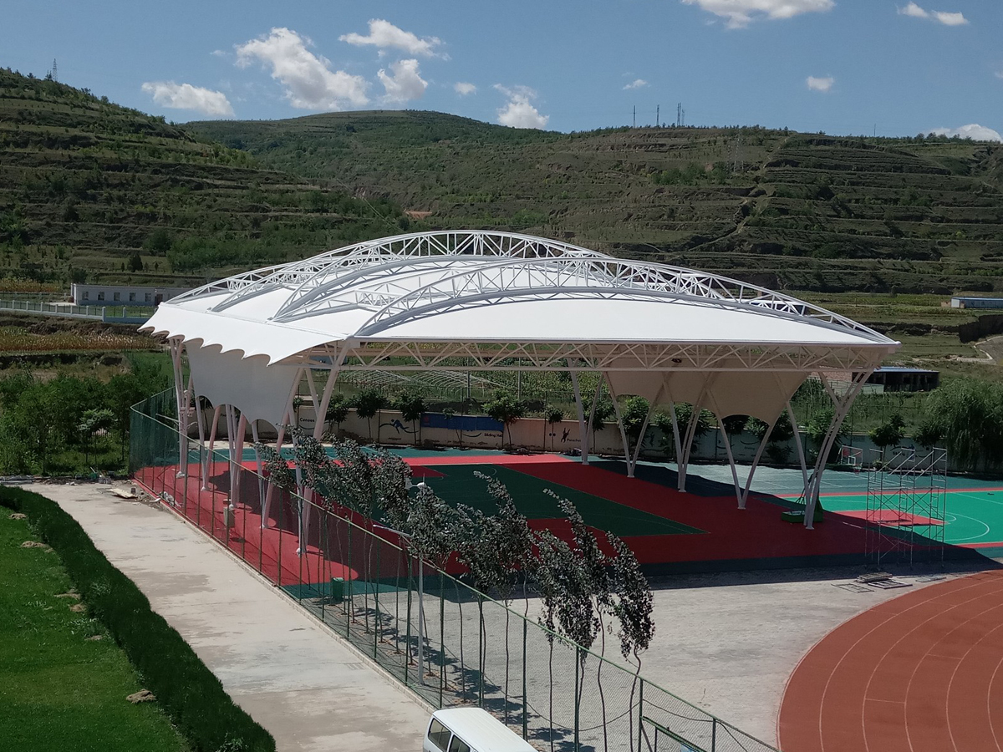
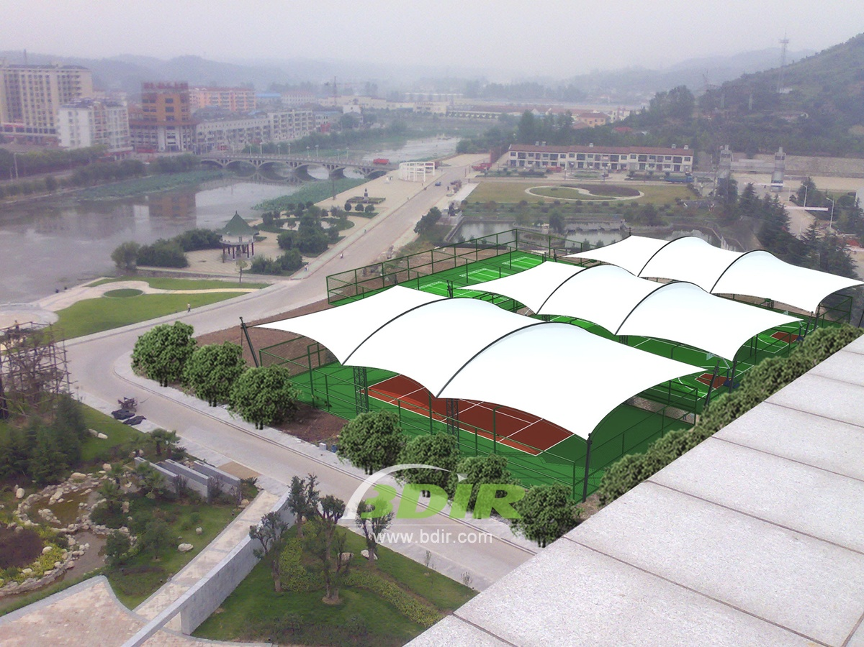
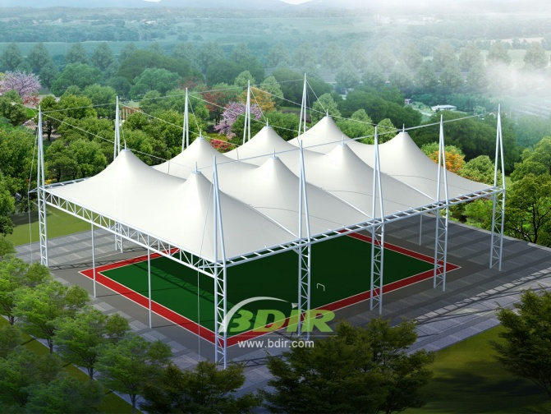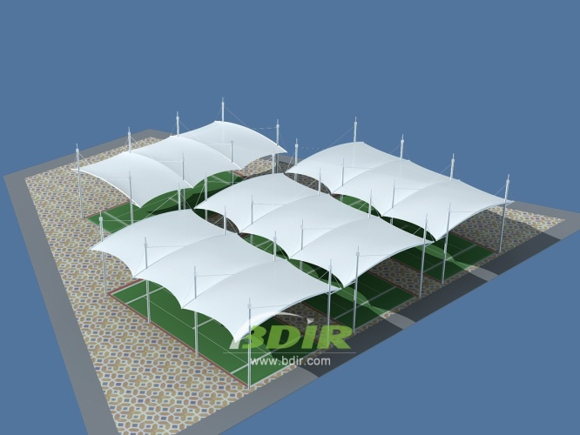

Badminton is typically played indoors because wind can affect the flight of the shuttlecock. So the Badminton court cover is very important.

Badminton court tensile structure will provide shade in the sunny months and shelter in the rainy months. They can be active all year and all weather playing space for the students and teaching staff. Besides, Badminton court roofing sheds are windproof, snow proof, rainproof, fireproof, shockproof.

We can provide an affordable alternative to permanent constructions for indoor badminton courts. We can help you to enhance your offering with the addition of all-weather badminton courts, or upgrade existing construction with brand new covers.

We can also provide a covered structure to your exact specifications and design badminton courts cover for you, including install lights and nets.

Badminton Court Tensile Structures Advantages:

1. Artistic: Give full play to the architect's imagination and reflect the mechanical beauty of architecture.
2. Economical: Because membrane has a certain light transmittance, lighting intensity and time can be reduced during the day, It's a great way to save energy. At the same time, gorgeous landscape can also achieve good advertising and publicity benefits.
3. Large span: Badminton court tensile structures can fundamentally overcome the difficulties encountered by traditional structures in large-span (unsupported) constructions, creating a huge unobstructed visual space and efficaciously increasing the space usage area.
4. Self-cleaning: PVC / PVDF membrane have a good self-cleaning function, while ensuring the service life of the construction.
5. Short construction period: With proper construction methodologies in place by design-build specialty contractors for tensile architecture, installation of tension membrane structures are often faster and more cost-function in comparison to traditional construction projects.

