12 White PVC Fabric Eco Dome Tents are scattered in Deep Forest
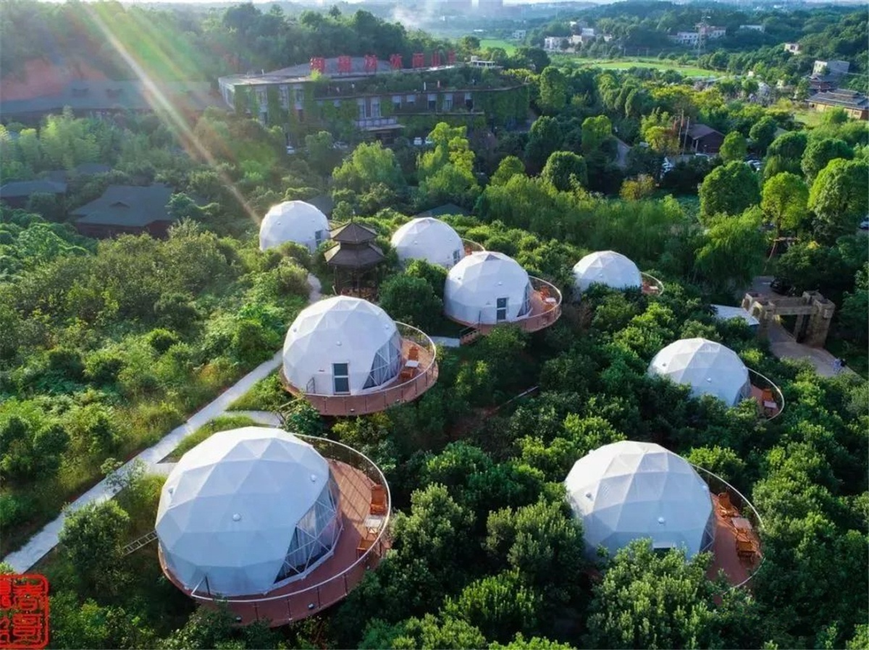
The Geodesic Dome Tent Hotel Base is developed by Yujinglin Leisure Villa Resort, built by BDiR Inc.The tent hotel is located in Quanyuan Community, Majiahe Street, Tianyuan District, about 10 kilometers away from Zhuzhou Shennongcheng Square.

12 white PVC membrane dome tented lodges are scattered among the manor’s bayberry forests. During the day, they are like a space capsule full of technology; at night, it looks like a small planet glowing. In the dome tent hotel, I feel that I am in a magical and mysterious dream world.

For each geodesic dome tent room, BDiR Inc. has designed bedroom, bathroom, vertical air conditioner, coffee table, small balcony, mahogany sofa, etc. It also adds a modern technology and full projector to play movies in the glamping dome. The roof of the dome tent cabin is transparent, and the visitors can look up at the stars in the room, which is more suitable for romantic lovers and high-end people. Each dome tent cabin is very close, and family can live and chat with each other on the deck balcony.

BDiR's spherical dome tent frame is made of high-strength steel structure and waterproof/flame-retardant/tear-resistant insulation to ensure the safety and stability of each tent house. The cost of a single dome tent is about 200,000 RMB, the building area is 60 square meters, and the indoor area is nearly 40 square meters. The big bed is suitable for two big and one small living.
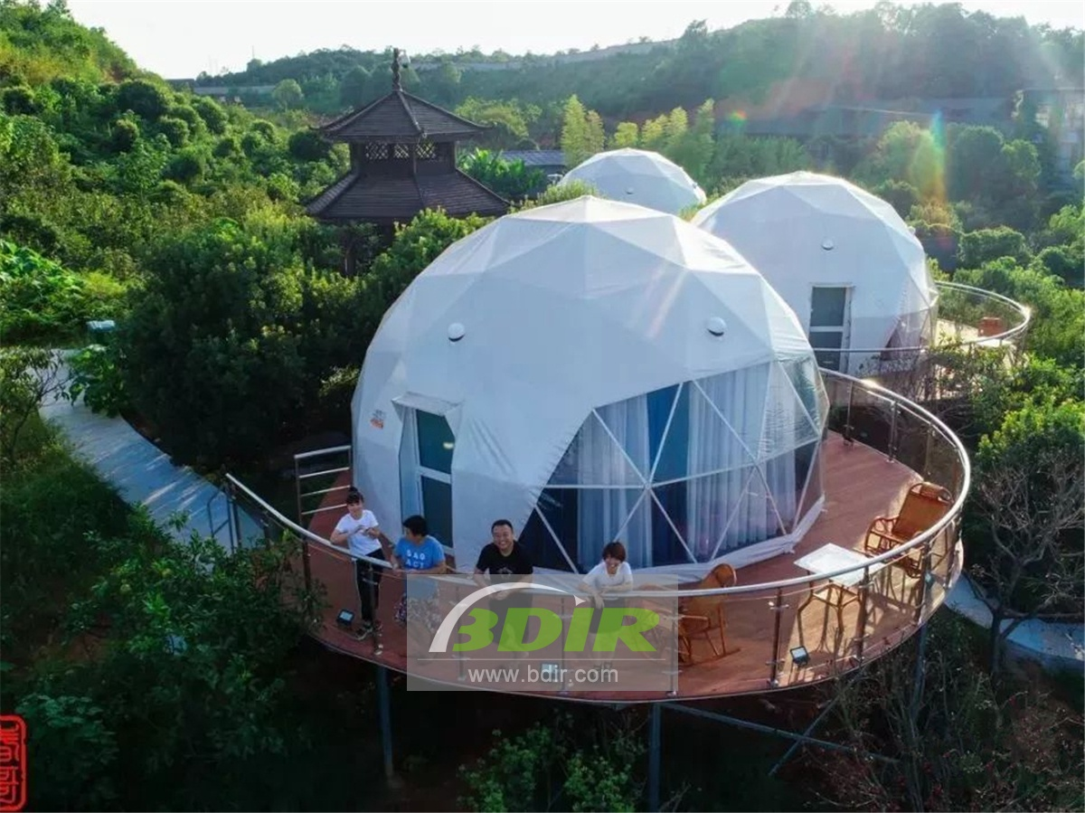

Technical advantages:
Each tent is located on a high platform which was built of steel frames and planks. Plants and animals can coexist unrestricted under each spherical tent platform. Each round tent room is designed with bedroom, bathroom, vertical air conditioner, coffee table, small balcony, mahogany sofa, etc. It also adds a modern technology and full projector to the wifi dome to play movies. Let you experience modern technology blockbusters outdoors!

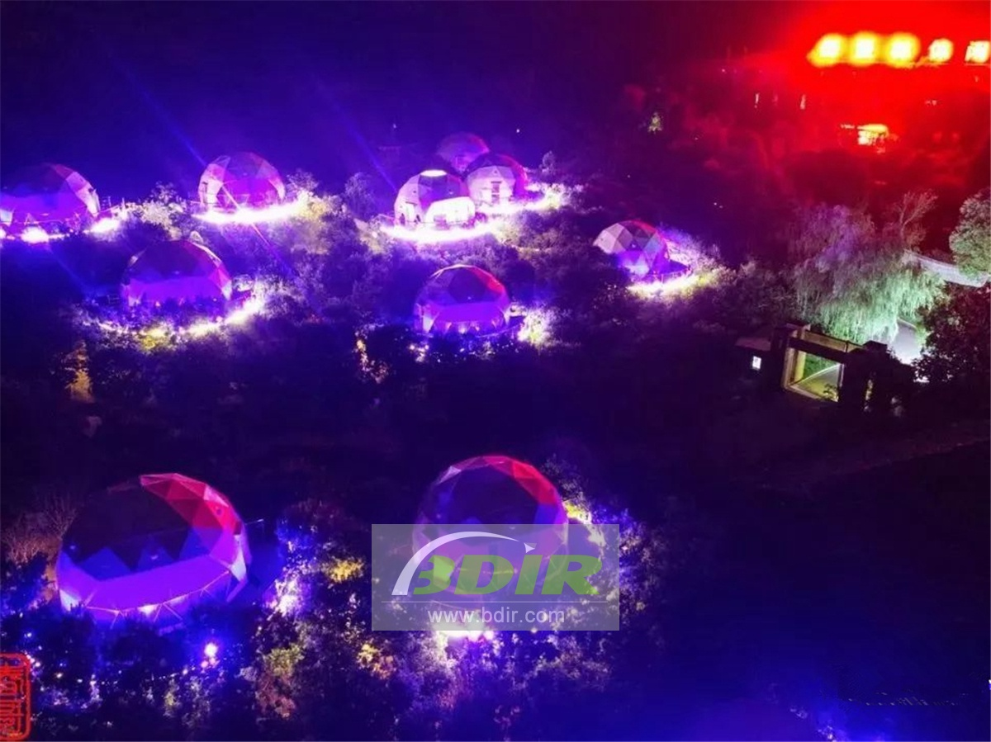
Reviews:
Based on our requirements and geographical environment, BDiR Inc. designed and built a unique tent resort for us! In particular, adding a technology-savvy dome cinema in dome, we can watch movies in 360 degrees! Super cool!

