Eco Friendly Tents House For Prairie Sustainable Resort Accommodation
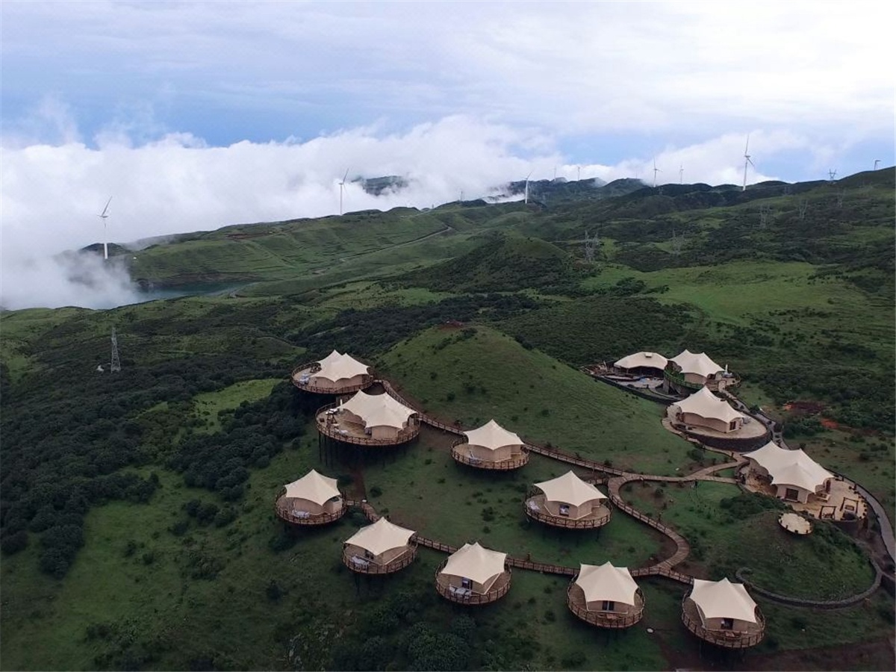
In October 2014, the operators of the Wumeng Prairie Scenic Area envisaged the establishment of a camping hotel in the scenic spot, so that people in the scenic spots and leisure activities can have a rest place. They succeed in finding the BDiR Inc., adopting a modular structure to design an outdoor tent hotel, which has very low requirements on the terrain and does not destroy its beautiful grassland natural environment.
Gu Ai Meng tent camp is located in Wumeng Prairie Scenic Area, Pingdi Yizu Town, Panxian, Liupanshui City, Guizhou Province, there is 120 kilometers from Liupanshui City Lushu Airport, 300 kilometers from Kunming Changshui International Airport, 330 kilometers from Guiyang Longdongbao Airport, and 150 kilometers from Qujing City Yunnan Province. There are high-speed access to the tent camp.
The tent campsite has a function area such as a restaurant, a book bar, a coffee bar, a bar, and a multi-purpose auditorium. The tented camp covers an area of more than 300 acres and the surrounding ecological environment is excellent. There are alpine meadow wetlands, wild azaleas, cattle and sheep in groups, birds and wild birds, and clear streams, waterfalls, blue sky and white clouds, which are interesting. The tent camp fully integrates and protects the camp's ecological environment in the design and construction, and it will never easily destroy the grass and the stone. You can experience the most original Wumeng scenery here.
BDiR Inc. Designed & built 13 tents for camp accommodation and leisure. 9 tent houses for guest accommodation, which Includes three tent rooms, two 286 m2 360° viewing family suites, two 107 m2 360° viewing room, four 74 m2 360° viewing room. Each room has a separate shower room and a viewing terrace.
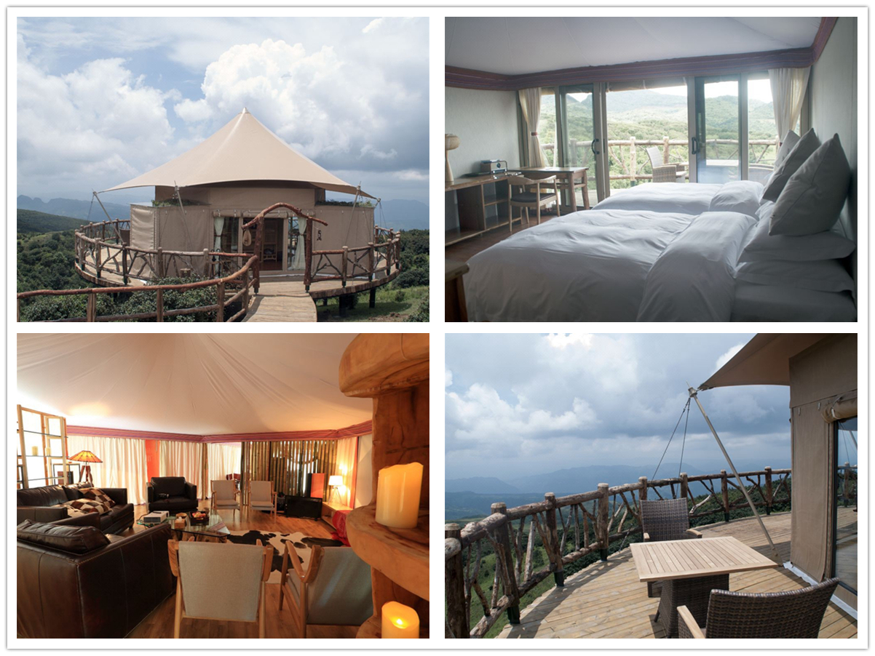

Technical advantages:
Because of its modular structure, Gu Ai Meng Tent Hotel can be easily and quickly built in the natural environment of the prairie. The design of the tented hotel is in line with the sustainable development concept. As a temporary building cabins, the natural environment around the prairie is rarely excavated and destroyed during the construction process, and it can be better integrated into the prairie ecological environment.

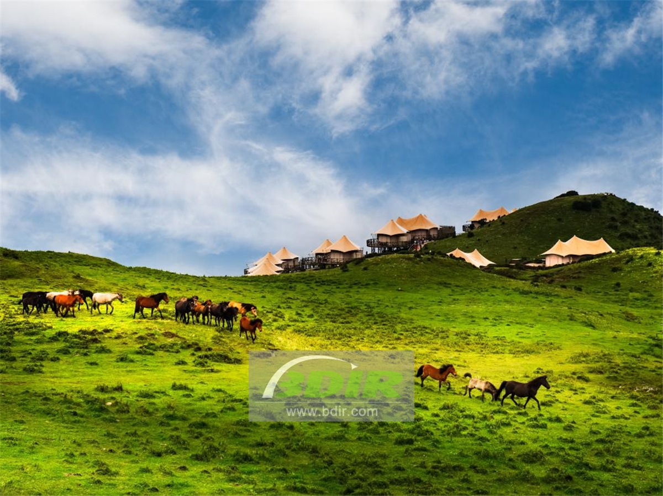
Reviews:
The person in charge of the scenic spot said: BDiR Inc. company fully integrates and protects the camp's ecological environment for the camp design, and which will never easily destroy the grass and the tree during the construction process. Thanks to BDiR Inc. for building the most original Wumeng scenery and make the people can enjoy the warm and luxurious accommodation!

