Eco Sustainable Hospitality Camping Resort with Fabric Roof Cottages
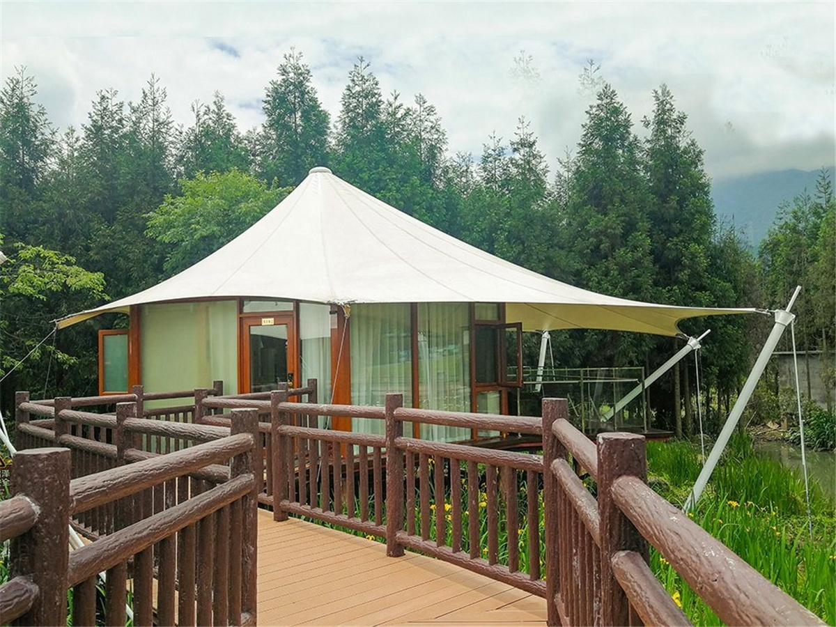
EmeiBanshan Qiliping Resort is about 1,300 meters above sea level, which is surrounded by 300 square kilometers forests. The forest coverage rate is as high as 90%. The PM2.5 of Qiliping is less than 20 long-time, and the negative oxygen ion content is 200-400 times higher than that of neighboring cities such as Chengdu. The Qiliping Hot Spring has long been famous, especially in the winter, and more than 60 steaming spring pools are bustling every day. It is a rare mountain resort with comprehensive tourism, recreation and leisure. Qiliping Tent Camp is located in the core area of Qiliping International Tourism Resort. The tent building blends the prairie style and the rustic style into an ecological friendly building that blends in nature. The camp resort has a tent accommodation area, which with a five-person football field, a self-service barbecue area, a self-service kitchen, a public bath, a public shower, a children's playground, tents house, and an area of over 1,000 m2 sunny lawn . It is available for large outdoor activities.

During the camp planning status, the camp designer found BDiR Inc.the hotel stated build some tent room for the camper after such a rich outdoor activity, having a unique and comfortable hotel room. In the original harmonious environment, BDiR Inc. built 7 sets of tent villas,which added a Unique holiday style to the camp. The tented camp features seven separate 360° viewing tents house, each with a large viewing and relaxing terrace. The interior facilities of the tent are equipped according to the standards of high-star hotels, and the floor heating is installed to provide 24-hour hot water. There is also a luxurious bath in the luxury tent.which is equipped with solid wood bed,with 360° floor-to-ceiling windows, oversized viewing terrace; through the 360° floor-to-ceiling windows overlooking the forest bamboo sea; overlooking the golden dome on the viewing terrace. The camp support: free parking Five-a-side football field; self-service kitchen; children's playground; forest meditation trail.
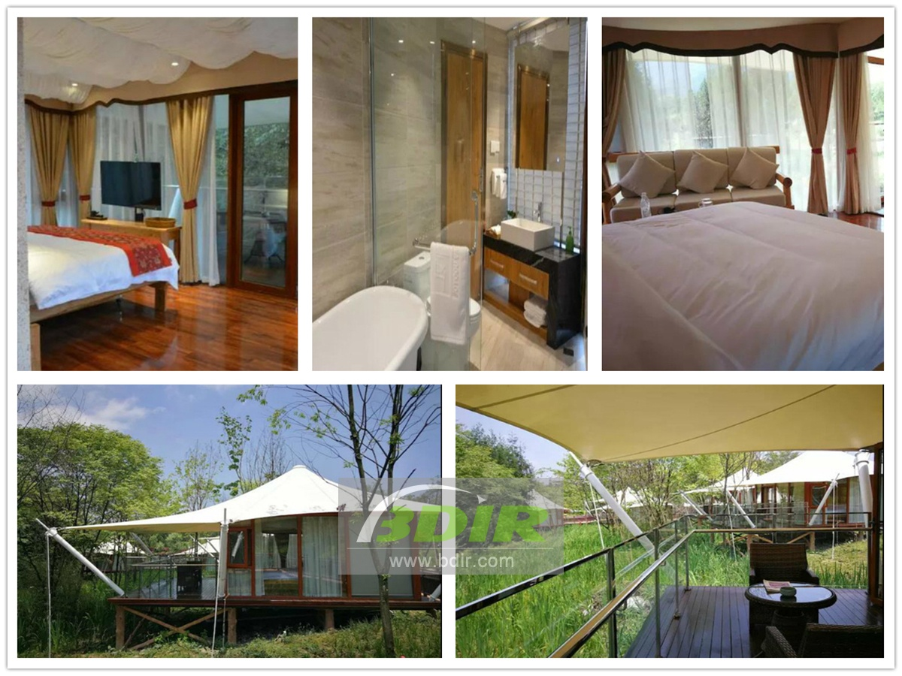
Technical advantages:
In order not to damage the environment of the camp, the tents were scattered throughout the camp. BDiR Inc. tent villa steel frame main frame, two-layer insulation and sealing PVDF top film, which with new exterior wall insulation composite hard wall board, with hollow tempered glass board, indoor is with16mm E1 grade composite floor, aluminum alloy glass door and window, internal fabric Decorating,which uses ecological laminate flooring to enhance platforms and passages, plants, flowers and animals can coexist unrestricted under each structure.

Reviews:
The Boss said: The successful construction of the BDiR Inc. hotel room adds a touch of holiday to the camp. Let the guests enjoy the beautiful outdoor environment and experience the unique luxury accommodation. Thank you BDiR Inc. for your hard work on this project!

