Eco Tensile PVDF Fabric Membrane Tent Hotel Manufacturer
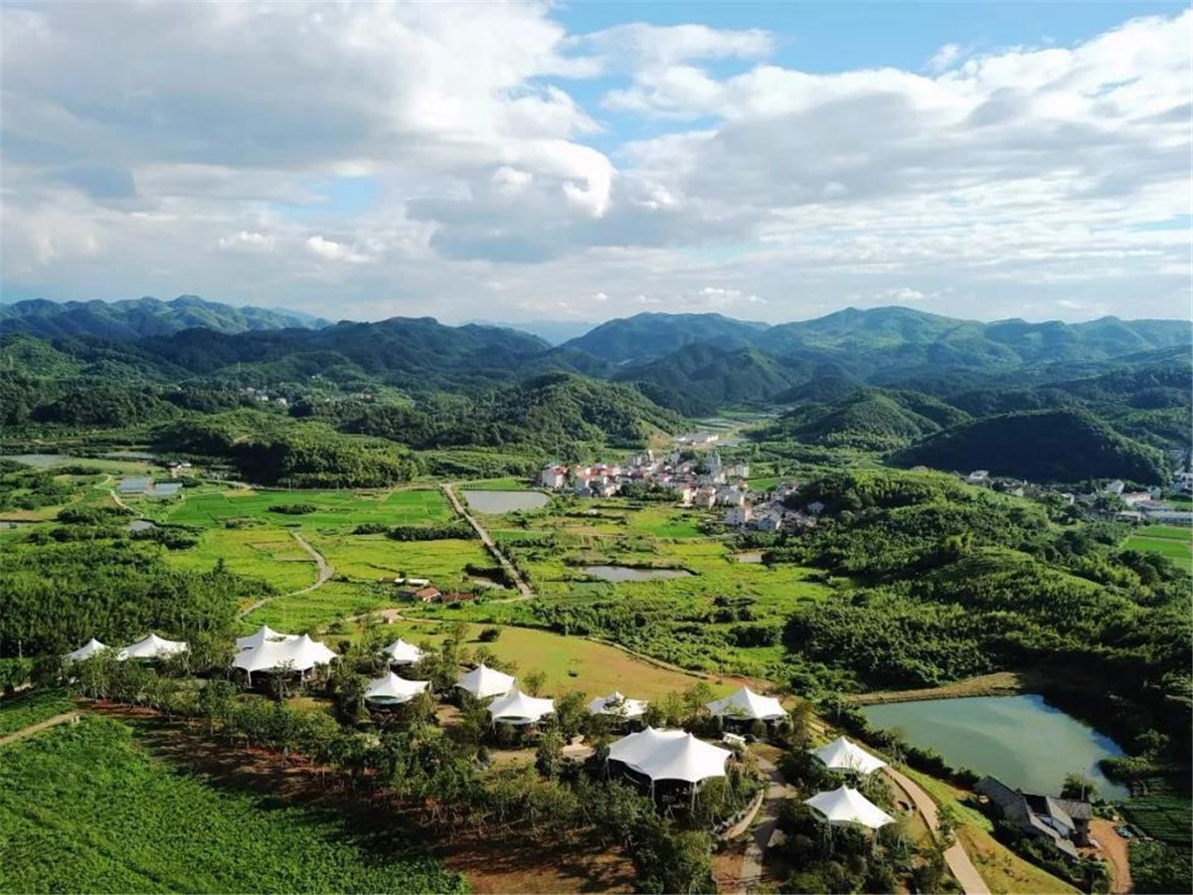
Zhuji • Spring Breeze Town Tent Hotel was designed by Yudi Building Engineering Design Co., Ltd., and built by BDiR Inc. Company. The luxury eco friendly tent hotel is simply and cleanly standing between the pine forests, which has 17 luxurious tent villas. There is a forest between the each two tent houses as a natural barrier, private and quiet. The tea garden landscape, the romantic bamboo forest and the exotic eco tent lodges blend together, so that the tourist can feel the quietness in the landscape garden,and the bird song insects, and experience the lifestyle away from the dust and embrace the nature.
The designer uses the "bamboo, mountain, tea" elements in tandem to design ideas, with simple and warm, fresh and natural themes, making full use of the unique elements of the valley to create a space full of romance and wild luxury. 17 tent cottages with a white and a streamlined canvas dome hang from the middle, which is particularly eye-catching in the green valley, and it is like camping.
Of course, as a outdoor mountain camp, the designer has set three types of tent villas: bamboo forest story (32.2m2), gray blue mountain (49.9m2) and tea fragrance (108m2) to meet different customers' accommodation needs as much as possible. These small tents can be said to be "5 star hotel room". The roof of each tent room is made up of three layers of fabric material, which has good sound insulation and heat insulation.
The overall color of the tent room is based on the earth color, with bright colors and metallic accents, which makes the entire space line tough. The shape of the furniture is mainly concise, which not only highlights the design style, but also highlights the individuality. The lighting accessories are mainly based on stability, plus light color, so that the space does not look too dull.
On the south side of each tent room, there is a full glass window for the widest view of the landscape. Each tented villas has its own taste. The unique color, furniture and decoration.
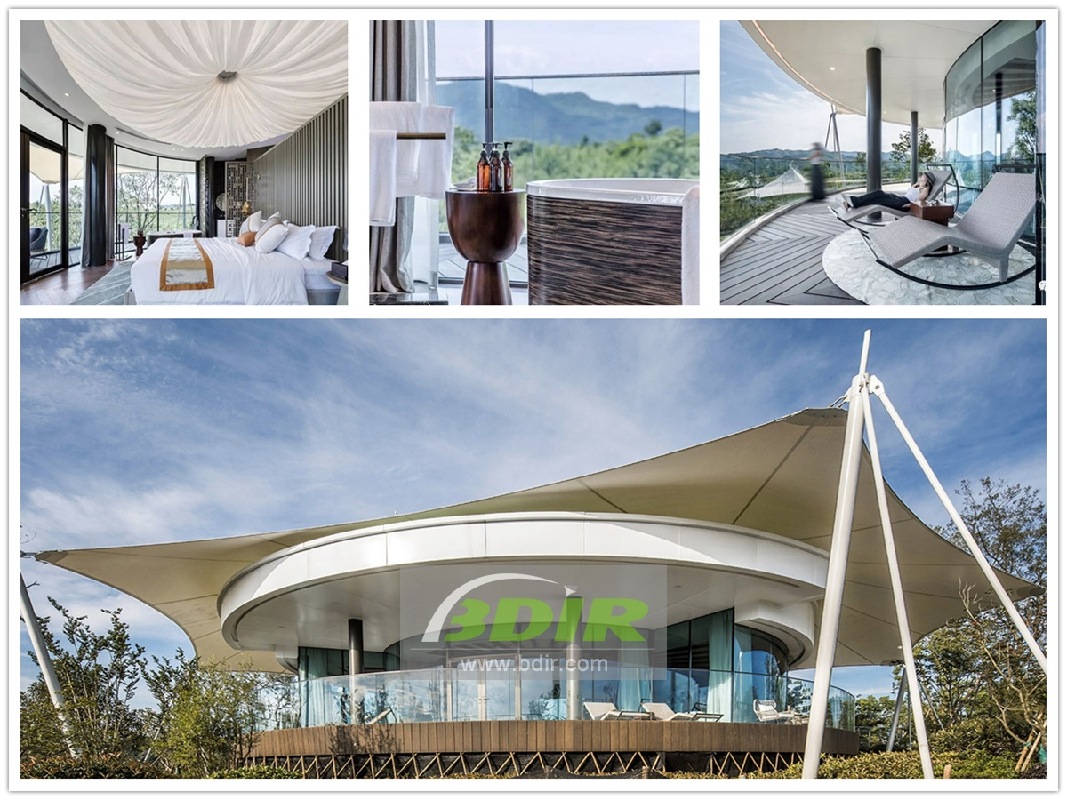

Technical advantages:
The tent hotel is made of high-strength aluminum alloy structure, which can resist the wind of 8-10 level outdoors. The double-layer covered tarpaulin of the tent is also resistant to wind and water, and it is UV-resistant. Therefore, it can be safe and comfortable without being affected by various weather conditions during camping.
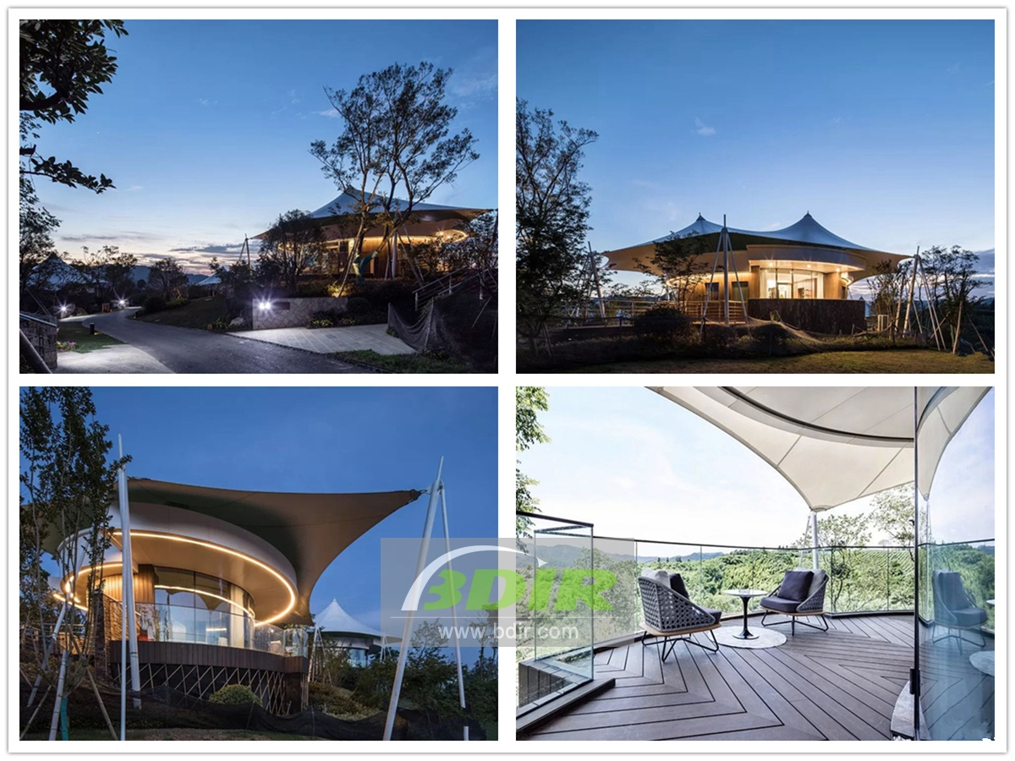

Reviews:
With its strong construction skills, BDiR Inc. presents our tent hotel perfectly in the world! During the engineering design and construction process, each subtle node has been repeatedly tested and demonstrated, which strives to build the tent villas with comfor and safety!

