Island Eco-friendly Tent Lodges – Design, Supplier, Manufacturer, Factory
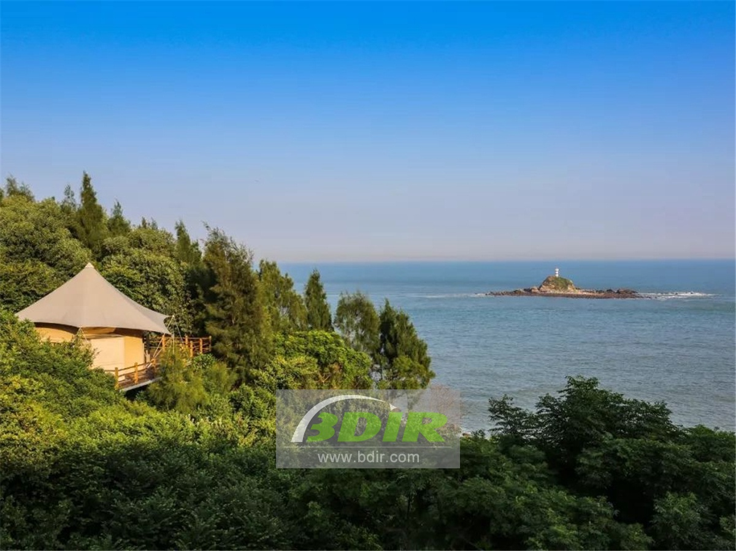
Dongshan Island Eco Tent Lodges,which is located in the southern coast of Fujian Province. The tent resort is located at the southern end of the South Golden Triangle Economic Zone in Xiamen, Fujian and Quanzhou. It is adjacent to the Taiwan Strait and belongs to Dongshan County, Zhangzhou City, Fujian Province. It is the second largest island in the Fujian province, the best tourist destination in Fujian Province.

A wilderness tent hotel was built by BDiR Inc. in 2017. The tent lodges are located in a secluded corner, backed by the Millennium Sufeng Temple, three facing the slopes of the sea. BDiR Inc. designed 8 tent rooms for the hotel under the premise of protecting the mountain environment. The main frame of the tent cabins is constructed of seawater corrosion resistant carbon steel and aluminum alloy, and the second layer of thermal insulation seals the PVDF membrane roof. The design and construction of the tent camp is very eco fridenly. The PVDF membrane structure tent is all prefabricated. It does not need to be bricks and Concrete. It can be quick installation and dismantling. It does not need to change the topography and vegetation landscape, and the ecological damage is minimized. The BDiR Inc. tent houses is best carrier for green eco friendly tourism.
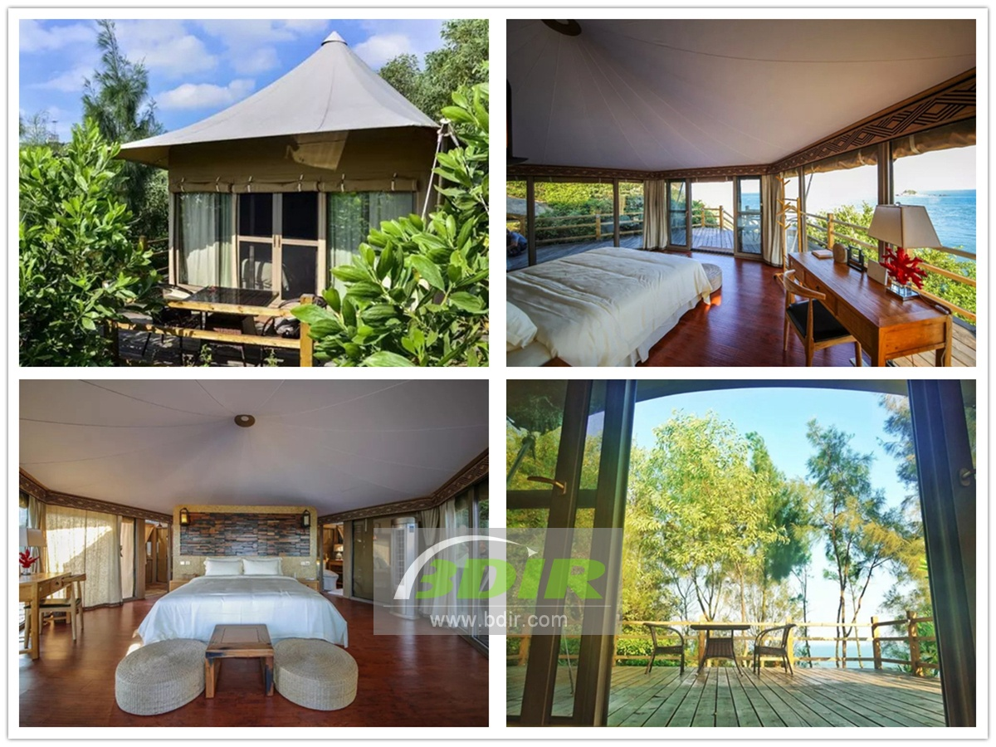
The camp has a strong sense of privacy. The location and layout of the eight tents are different. According to different locations, different tents correspond to different poetic and suitable names. “Yuyu”, “Muyun”, “Muzhi”, “Qi Xia” "Ting Tao", "Wen Chan", "Yao Yue" and "Yuan Hao". In the tent rooms which faces the sea view use floor-to-ceiling glass windows to let the scenery of the mountains and seas penetrate. There are 360 panoramic rooms, each functional area is separated by logs, with a special boat wood decorative wall in southern Fujian, and with an observation deck. The "Tingtao" tent room also comes with a private deep-sea hot spring pool. The tents are constructed with three layers of different structures. The waterproof and sun protection factor of the fabrics is very high, and the beauty and solidity are taken into consideration. The wind and rain are no longer worried about, and the shapes are different, but they all strive for natural simplicity.
The area of the tent ranges from 24 square meters to 36 square meters, and all the furniture is decorated with logs. The interior of the tent is very beautiful, which was separated by logs. The whole tent is dominated by white ochre, which accompanied by the green outside the window and the blue of the sea. With air conditioning, shower, and tea seats are all available. The view from the tents touches the sea,when you push the window and sees the scenery. It is surrounded by the sea and the forest of the surrounding mountains, which makes full use of every gift of nature.
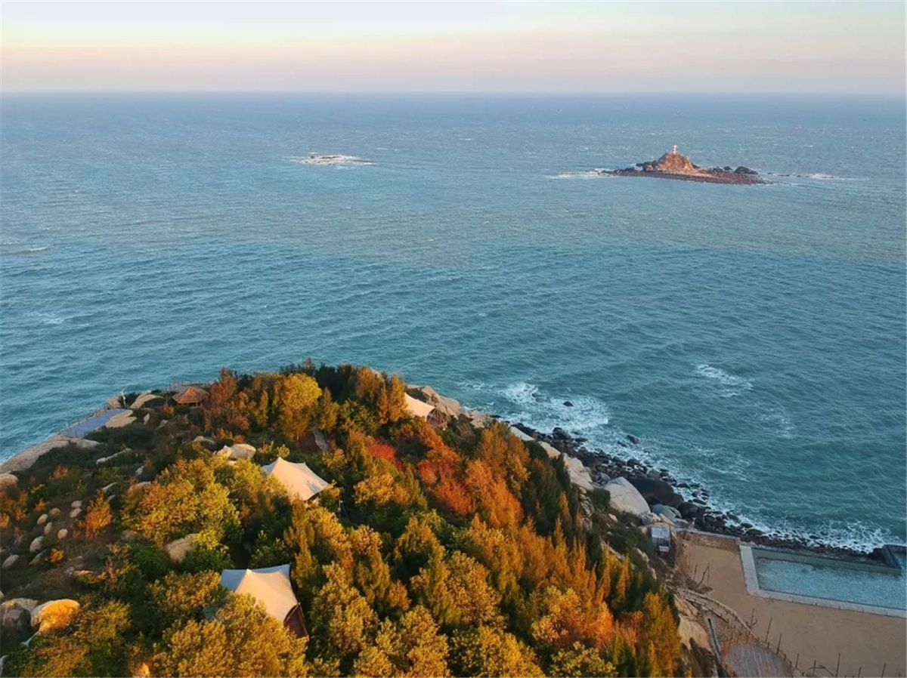
Technical advantages:
The design and construction of the camp is very green. The tent structure is all prefabricated. It does not need to be bricks and tiles. It is easy for installation and save much time build. It does not need to change the topography and vegetation landscape, and the ecological damage is minimized. The best carrier for green tourism.

Reviews:
Based on our design, BDiR Inc. engineers gave a lot of optimization suggestions,which makes the entire tent house safe and secure! After several high-intensity typhoons, it still stands as ever! It is environmentally friend!

