Hotel Tents | Luxury Tent Hotel | Resort Tents | Luxury Eco Resorts
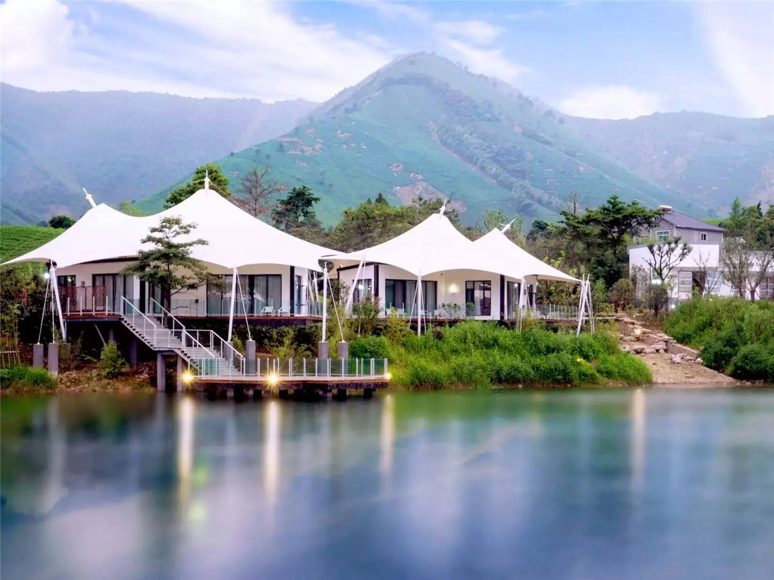
Anji County, Huzhou City, Zhejiang Province, the United Nations “habitable place for human settlements”, the country's first ecological county. Jianxian County has been in the Eastern Han Dynasty for two years and has a history of more than 1,800 years. Known as the "China White Tea Capital" and "China Bamboo Township". Anji has a pleasant climate and which is a subtropical maritime monsoon climate. It is mild and humid with pleasant climate. The annual average temperature is between 15 °C and 17 °C. The precipitation is mainly spring rain, plum rain and typhoon. There is drought in July and August.
The “Tent Cabin” advocates a lifestyle that is far away from the dust and embraces nature. When you stay in the “Tent Cabin”, you will leave your troubles and fatigue behind, and you will feel the aura of the heavens and the earth in the mountains and rivers. Here,you can enjoy returning to the beautiful nature, and the nature and humanity are in harmony, the original ecology and the soul resonate. Unlimited and beautiful style, all in the membrane structure tent. The tent hotel is also a practitioner of environmental protection. The tent hotel is a non-permanent building that maximizes the ecological environment of the scenic spot. Each “Tent cabin” has its own eco-circulation system and renewable energy heating system to minimize the hotel's own energy efficiency.
According to the concept of James Lin, the Anji tea culture and geographical environment, BDiR Inc. designed and built 11 tent structure villas. The tent villas adopts a combined steel-wood frame, which can be safely and stably used in different terrains. The tent house adapts to the temperature environment of -30 ℃ to 70 ℃. The roof is made of ultra-light PVC, PVDF materials, with good waterproof, UV-resistant, tear-resistant properties, as well as B1/M2 fire resistance. The interior of tent room is decorated with bedrooms, bathrooms, terraces and other areas, furniture, flooring, lighting and other facilities. You can also experience the comfort of a five-star hotel in the wild.
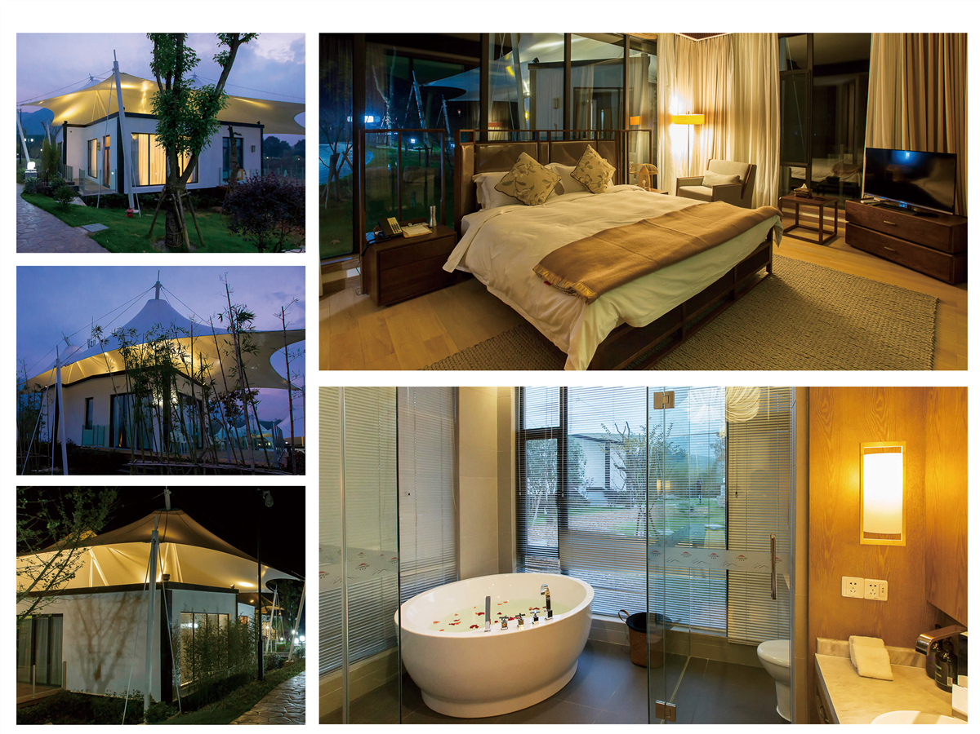
Technical advantages:
How to avoid tent accommodation is easily affected by the external environment?
The overall tent of the hotel is made of aluminum alloy frame, which with strong wind and snow resistance. The roof cloth is made of double-layer PVC waterproof tarpaulin. It is also resistant to wind, rain and sun. It is guaranteed not to be in camping. It will be affected by all kinds of weather, and it is very safe. The interior is decorated with fabrics to make the stay more comfortable!

Reviews:
James Lin said: BDiR's bold ideas and designs make vacationers enjoy a different luxury accommodation in a resort tent villa. During the day, the tent blooms like a blossoming tea in the tea garden, and the night is decorated with stars and decorations. so gorgeous!

