Sustainable Wild Luxury Dome Tent Hotel for Qiandao Lake Resort
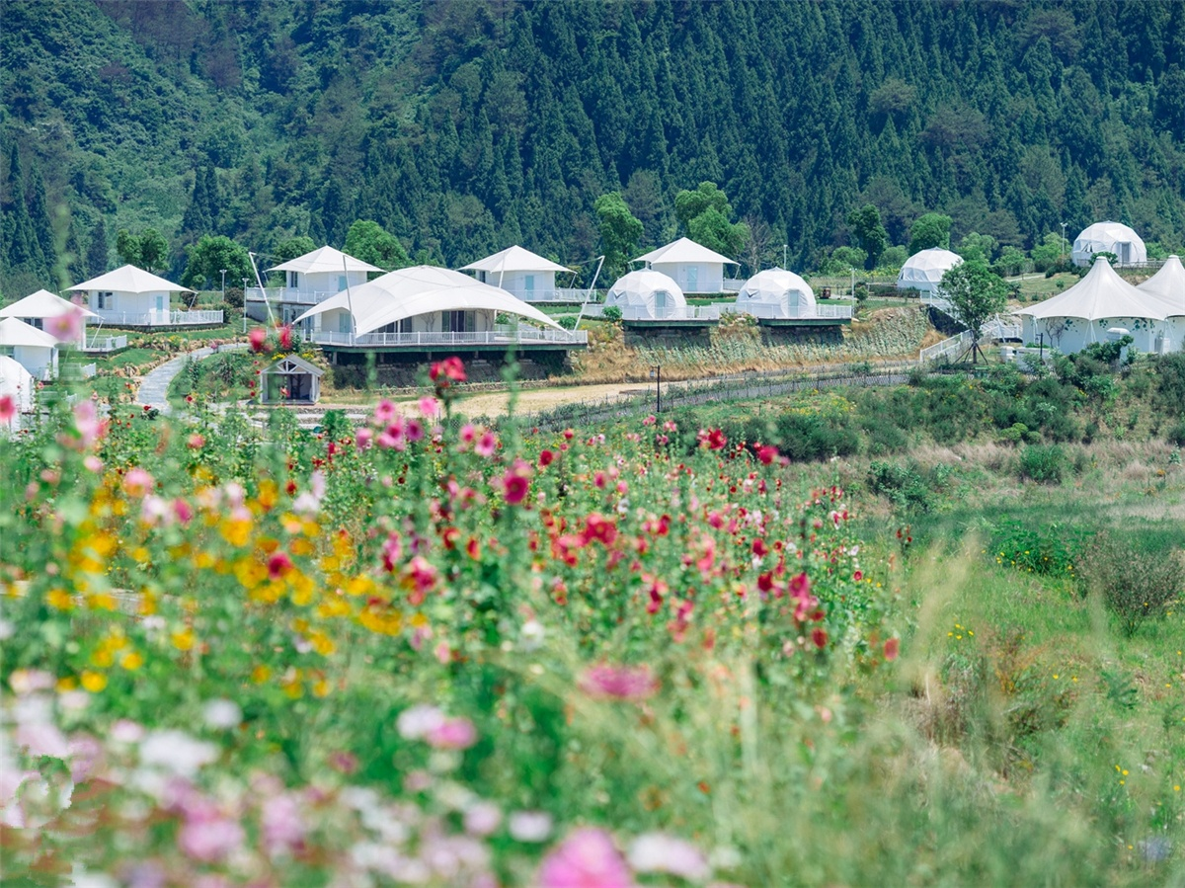
The Qiandao Lake Wild Luxury Tent Hotel Project built by BDiR Inc. in May 2016.This is the first tent theme hotel in Qiandao Lake. The hotel tent is located in the Equestrian Park of Jinxian Bay International Tourism Resort. When you enter the park, you will see the green grass and the white and colored tents set in the lawn and flower sea. BDiR Inc. combines eco system of the Qiandao Lake, design&bulid 15 tents for resort. The tent house are named by constellations.

The 15 tent rooms are all built in the form of domes, each tent fixed on a wooden platform. BDiR Inc. designed tensile fabric membrane tent for hotel reception and bar. The hotel reception is a tent-shaped house that is located the entrance of the resort. The main body is a brick-and-wood structure. The exterior of tent house is decorated with green plants and vines. The reception house is fitted lining wood floor and wood-grained tables and chairs, and the staff will lead you to your constellation tent room after check-in.

The geodesic dome room is designed with a spherical tent of only 28.26 square meters,it is equipped with big bed, cloth, air conditioning, lighting, exquisite home, bathroom equipment and so on. The outside of the tent cover with wither PVC fabric membrane, and the interior is divided into two parts by a white wall: the bedroom and living room, the bathroom and shower cabin behind the partition. The roof of tent house which is facing the bed is a transparent skylight with a remote control switch, and you can look up at the stars in bed. The decoration in the dome tent room is so large that the details are full of romantic fairytale colors, and the tent room also has a special telescope. The tent villas was only used with eco-friendly glue, no paint, and it was very sustainable geodesic dome accommodation. The tent villa is supported by a steel frame, and the facade is Pvc coating . At the same time, In the wall of tent house is filled with “local material” horsehair, which is warm in winter and cool in summer, and it has good sound insulation effect.
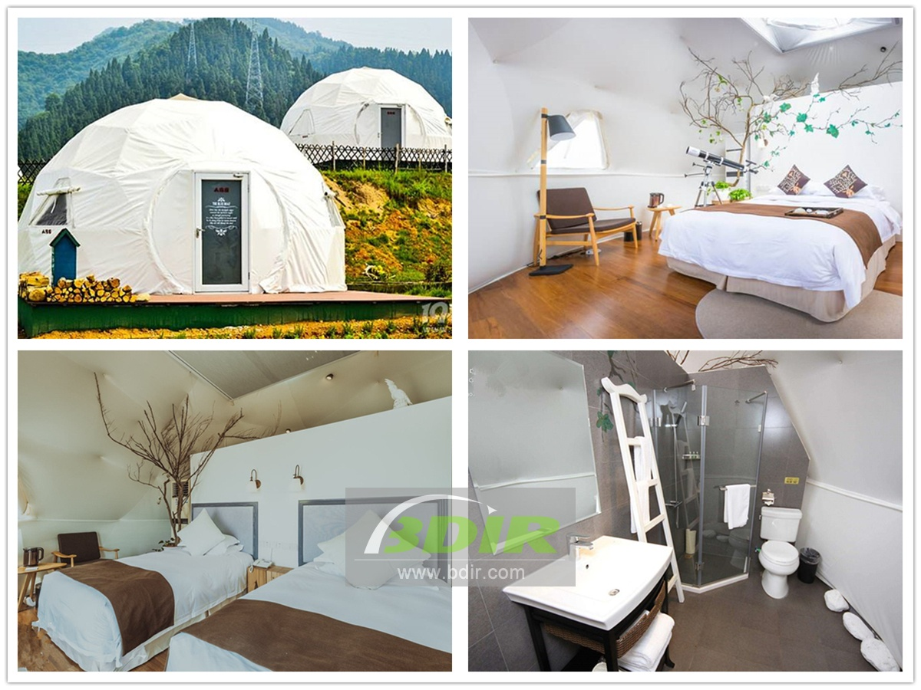

Technical advantages:
The geodesic dome tents are spacious and bright,which is equipped with terraces, floors, walls, observation decks and other perfect tent functions, as well as large beds, fabrics, air conditioners, lighting, exquisite homes, sanitary equipment, etc. Which in order to create a five-star outdoor luxury hotel. Because of its cold winter, the design is filled with horsehair to improve the warmth and sound insulation of the tent.
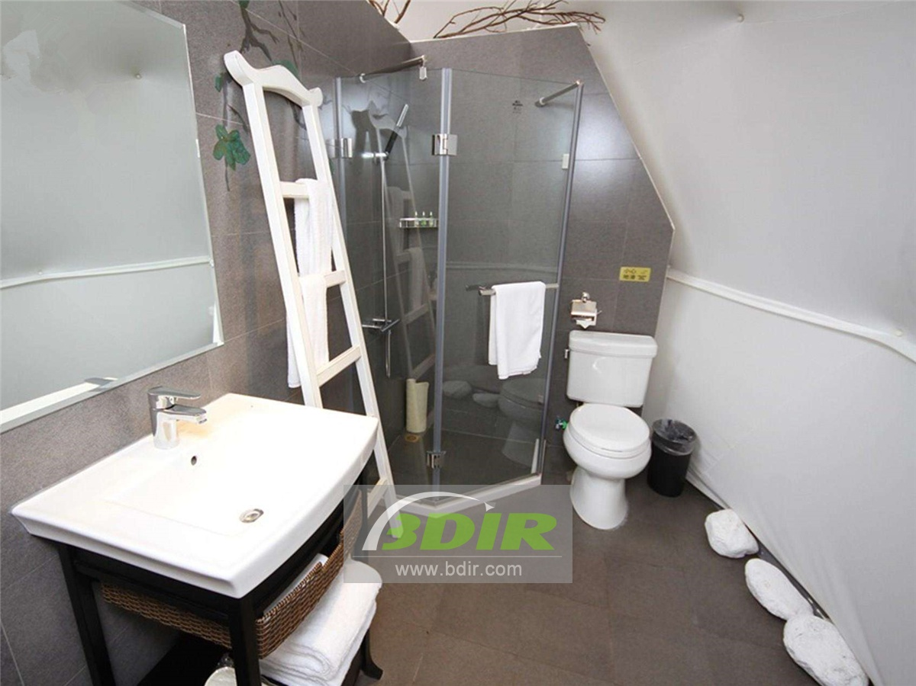

Reviews:
BDiR Inc. is specializing in design and installation technology,we pay attention to every detail and strives to build a safe and comfortable tent house. They built a luxurious outdoor dome pod for us, bringing a unique luxury experience to our guests!

