Big & Large Camping Tents, Luxury Camping Tents, Canvas Camping Tent

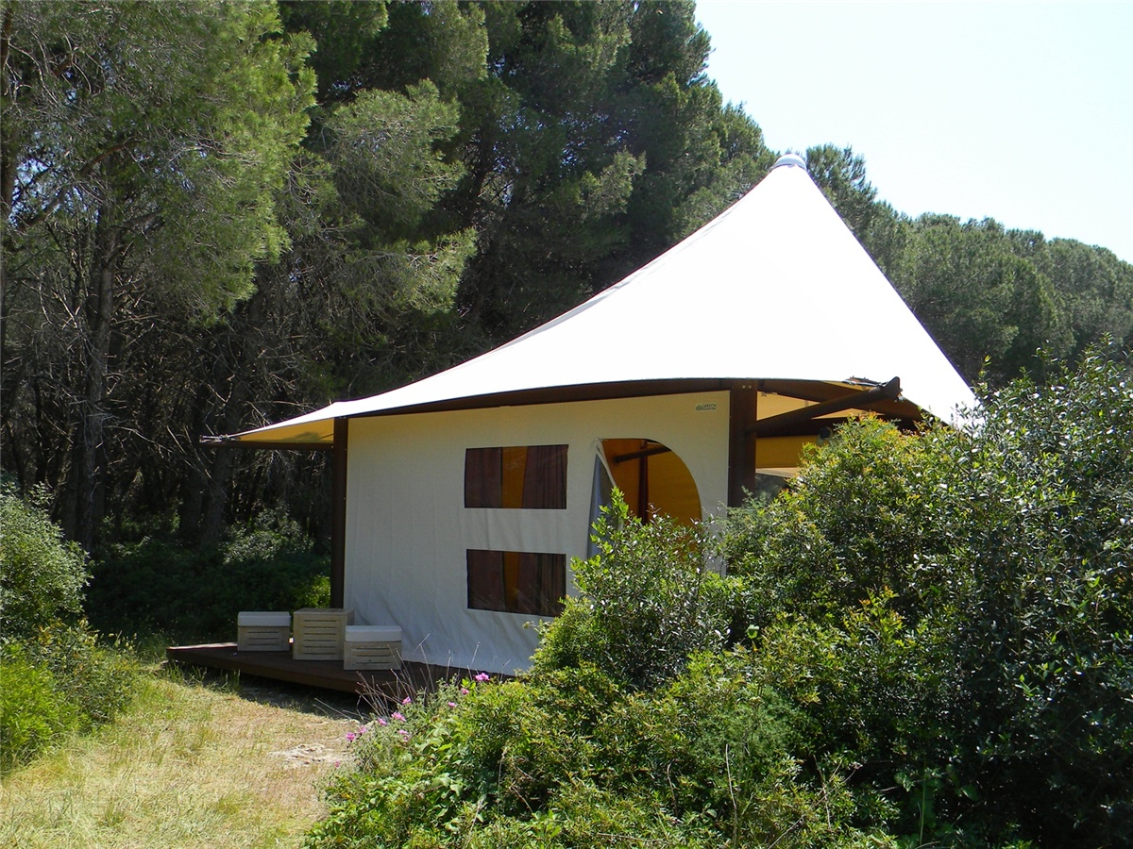
In August 2012, Rajib Roy found us through Google search and he wanted to build a unique campsite on his farm. Based on Roy's requirements and its local geography, BDiR is designed to replace simple camping tents with semi-permanent tent house. All tent cabins are finished with high quality steel and special fabric membrane. The tent structure is 56 square meters and which is divided into 26 square meters of outdoor space and 30 square meters of indoor space, which is including 1 bedroom, 1 bathroom with shower and 1 dining area. Modules can be converted in different ways,and it adds interior furniture (bed, furniture, sofa bed, table, chair, wardrobe, kitchen furniture, bunk beds, bedside tables...)

The main structure is galvanized steel with heat-painted epoxy resin powder. The floor is assembled from solid wood and serrated outer surface plates with a smooth internal surface. The top cover is made of 1000g/m2 flame retardant M2 PVDF fabric, and the inner layer is waterproof pvc fabric cream beige. Wire tension cable is used. The exterior walls are beige PVC and transparent pvc windows and with mosquito nets as well as zipper openings. The walls of the main façade are vertical sliding shutters made of clear crystal with an electric on/off system, and the side rails and upper cabinet are made of heat-painted aluminum. The interior walls are made of natural wood. The total area of the tent is 7m x 8m and the internal area is 5m x 6m.

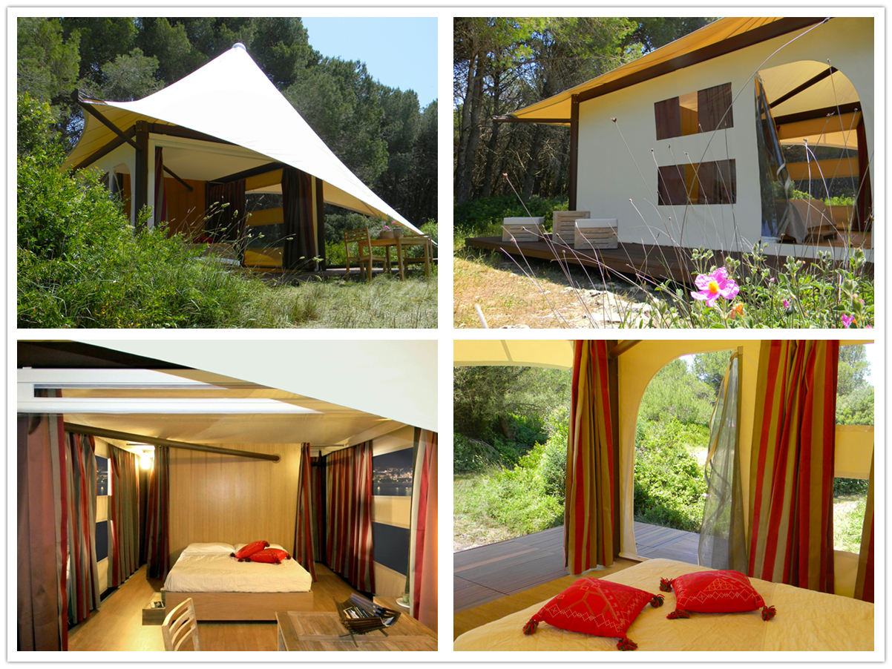

Technical advantages:
Roy wants to build at the fastest speed and meet the campers before the summer?
The materials required for the construction of the tent house are steel components, aluminum alloy, PVC waterproof tarpaulin, glass wall, etc. These are manufactured in advance at the factory and then processed and transported to the scenic spot for direct installation,which according to the construction structure and local geography. The environment can usually be completed within a few days.

Reviews:
Roy Said: BDiR designed the perfect Glamping Tent Hotel for us. They completed the design - life - building work in the quickest way, and completed the renovation before the summer season, which gave me more summer business hours. Thank you BDiR for your full cooperation!

