Tent Structure | Tented Cottage - Design, Supplier

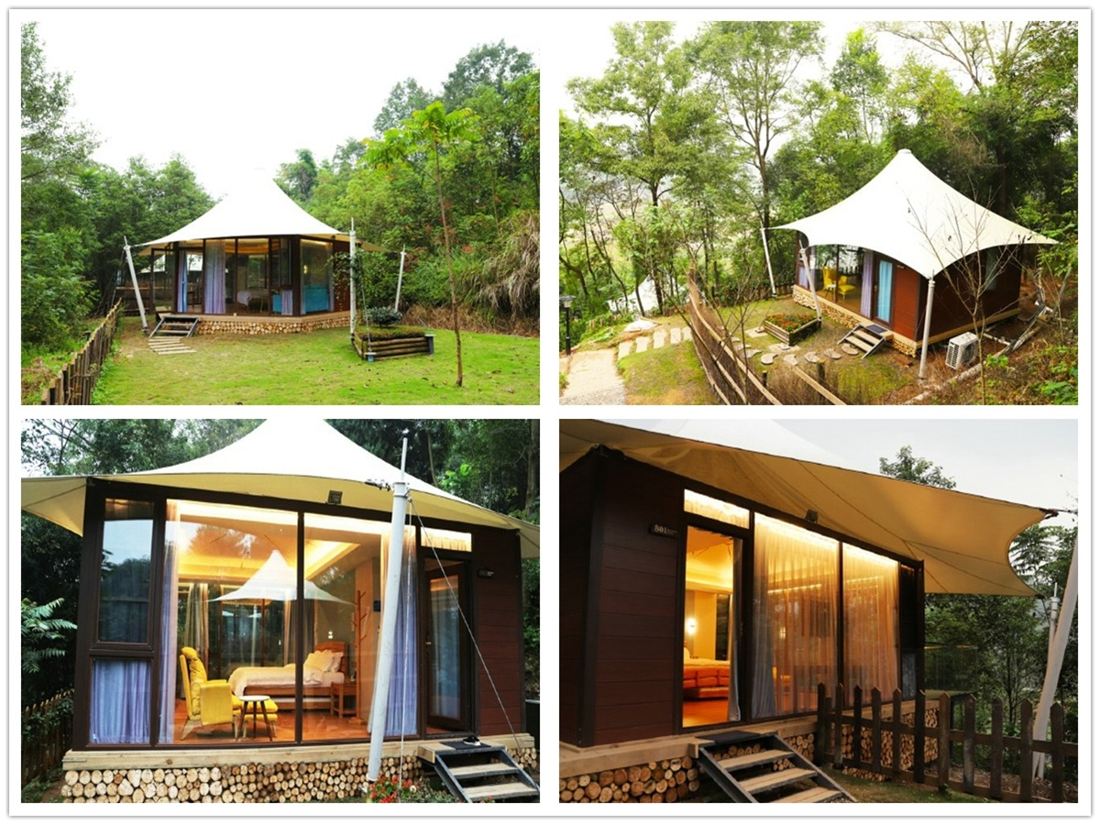
The tent camp is surrounded by 400 acres forest and countryside. It is a rural complex camp integrating with ecological breeding, catering and leisure, conference development, parent-child education and pleasant vacation. It has five farm characteristic areas: organic ecological agriculture planting area. Ecological farming area, creative agriculture sightseeing area, farming interactive experience area, catering and leisure reception area.
The person in charge of the camp was found BDiR Inc. and he wanted to build several unique tent lodges as accommodation rooms for city people's vacation. In combination with the local environment and camp layout, we built 5 single-story high-rise tent structure villas in Halfway up the mountain, each of the camp can accommodate 2-3 people. The five tent villas are scattered on the mountainside. The tents with snow-white roof are hidden in the greenery of the forest. If they are looming, the ecology and privacy are self-evident, all of them which reflects the characteristics of wild luxury and outdoor life. Each membrane roofing tent cottage has a separate 40 square meter small courtyard.
The tent structure lodge is constructed of high-strength aluminum alloy and carbon steel. It is matched with a high-strength white fully waterproof PVDF fabric to ensure product long services life and reduce maintenance intervals. The luxury tent villas uses a tensile membrane structure as the roof. The membrane structure tent house is based on styling and color science. Combining with the natural environment, ethnic customs and human geography, according to the architect's creativity, the curve and shape that are difficult to achieve by traditional construction are built. The luxury outdoor tent hotel with its beautiful shape and unique shape is full of fashion charm and blends with nature.

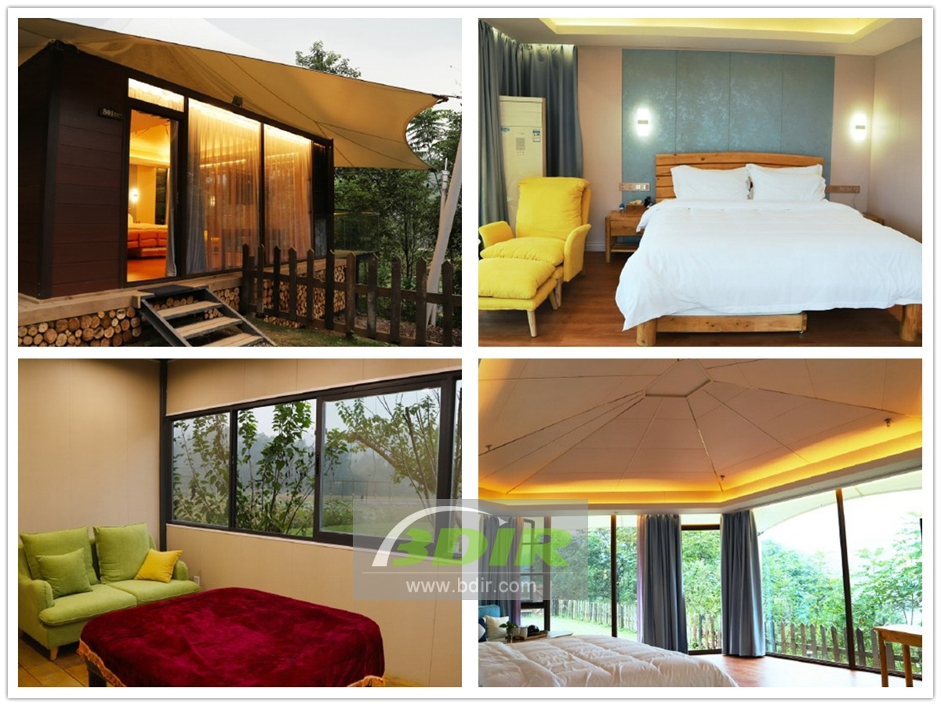

Technical advantages:
How to make a couple with children who can lie on bed and count stars?
The tent camp uses a translucent film tarpaulin to reduce lighting intensity and time during the day. At night, the transmission of colored lights forms a beautiful landscape, which increases the advertising effect and dream color. After turning off the lights, you can see the stars in the sky.

Reviews:
Boss Yu said: The hotel tent designed by BDiR can create a feeling of integration with nature. The tenants can't leave the tent at night, and they can see the stars in the bed. Many parents said that children especially like to lie on bed at night and look up at the stars.

